Design and Development of Virtual-campus System Using PHP & MYSQL



Department of Computer Science & Engineering (CSE)

The Millennium University

Momenbagh, Dhaka-1217, Bangladesh

Websi[te: https://themillenniumuniversity.edu.bd](https://themillenniumuniversity.edu.bd/)

Design and Development of Virtual-campus System Using PHP & MYSQL

**By**

**Yasna Afrin**

**312CSE0004, 19th Batch,**

**Department of Computer Science & Engineering**

**A Project Submitted to the Department of computer Science & Engineering for the Partial Fulfillment of the Requirement of the Degree of Bachelor of Science**

**In**

**Computer Science and Engineering**

**Department of Computer Science & Engineering**

The Millennium University

Candidates Declaration

The project title is **“Design and Development of Virtual-campus System using PHP & MYSQL”** has been composed by us & all the works presented herein are original and our own. We have declared that this work has not been submitted anywhere for any academic degree.

Yasna Afrin

ID: 312CSE0004

Batch: 19th

B.Sc. (Engr.) in Computer Science & Engineering Department of Computer Science & Engineering The Millennium University

Momenbagh, Dhaka-1217, Bangladesh

Certification

The project title is **“Design and Development of Virtual-campus System using PHP & MYSQL”**, Submitted by Yasna Afrin, ID No. 312CSE0004, Batch: 19th to the department of Computer Science and Engineering (CSE). The Millennium University has been accepted as satisfactory for the partial fulfillments of the requirements for the Degree of Bachelor of Science in Computer Science & Engineering and Approved as to its style and contents.

Supervisor

(Dr. Md. Zahedul Hassan)

Chief Scientific Officer

Bangladesh Atomic Energy Commission Dhaka-1000 Bangladesh

Table of Contents

Pages

Abstract………………………………………………………………*…………………………….*8

Acknowledgement......................................................................................................................10

Chapter-1

Introduction……………………………………………............................................................11

Chapter-2

System Planning of Virtual-campus System

2.1 System Planning…………………………………………………………………………...12

2.2 Project Aims and Objectives………………………...........................................................*.*12

2.3 Background of Project…......................................................................................................12

Chapter-3

Advantage & Disadvantage of Virtual-campus System

3.1 Advantages of Virtual-campus System……………………………………………………14

3.2 Disadvantages of Virtual-campus System………………………………………………....15

Chapter-4

Architecture of Virtual-campus System

4.1 Architecture of Virtual-campus system…………………………………………………..16

4.2 Use case Diagram of Virtual-campus system.....................................................................17

4.3 Methodology of Virtual-campus system…….…………………….……………………...17

Chapter-5

Design of Virtual-campus System

5.1 User Sign_in Page…………………………………………………………………………21

5.2 User Registration or Sign_up Page………………………………………………………..22

5.3 Sharing Important Posts Page….........................................................................................22

5.4 User Profile Information Page……………………………………………………………23

5.5 Live Conversation/chat System Page.................................................................................23

5.6 Post System Page….........................................................................................................24

5.7 Comment System Page…..................................................................................................24

5.8 Like System Page…..........................................................................................................24

5.9 Home Page…..................................................................................................................25

5.10 Timeline Option Page………………………………………………………………….26

5.11 Friend Request Option………………………………………………………………...26

5.12 Virtual-campus Drag and Drop box…………………………………………………..27

5.13 Settings/Change User Information Option…………………………………………....28

5.14 Connection to the social Communication Sites……………………………………….29

5.15 Database Design………………………………………………………………………31

5.15.1 Relational Database………………………………………………………………...31

5.15.2 Entity Relationship Model………………………………………………………….32

Chapter-6

Project Requirements

6.1 Language and Tools ………………………………………………………...................34

6.2 HTML …………………………………………………………………………………34

6.3 CSS ……………………………………………………………………………………35

6.4 JavaScript ……………………………………………………………….…………….35

6.4.1 Java Script is easy to learn ………………………………………………………….35

6.4.2 Ajax Function…………………………………………..............................................36

6.4.3 JQuery Language………………………………………….........................................36

6.4 MySQL ………………………………………………………………………………..36

6.5 PHP…………………………………………………………………………………....36

6.5.1 Why PHP …………………………………………………………………………...37

6.5.2 Sanitize Function…………………………………………........................................37

Summary ………………………………………………………………………….......37

Chapter-8

Conclusion……….……………………….……………….…………………………….....38 Appendix…………………….………………………………………………………….....37

Abstract

A virtual campus refers to the online offerings of a college or university where college work is completed either partially or wholly online, often with the assistance of the teacher, professor, or teaching assistant. Many established and mainstream colleges and universities now offer many courses (or entire degree programs) either partially or wholly online. It gives an overview of the theory of virtual universities and e-universities and attempts to clarify our usage of the terms. It gives an overview of the chapters, in an expanded table of contents. It considers a thematic approach to the material, and links forward to sections, subsections and “objects” within the chapters. It gives an overview of the currently popular topic of Critical Success Factors for e-universities.

We have used HTML, CSS, JavaScript, PHP and MySQL, jQuery language, GitHub, Ajax function, sanitize function to develop this system.

**Dedicated to my Family**

Acknowledgement

In the name of almighty Allah, I am obliged to state that; the completion of my work is achieved with the blessing of almighty. The successful completion of this work is not an individual effort of mine. At first I would like to thank my supervisor **Dr. Md. Zahedul Hassan** sir. Who always inspired me to work more and more to achieve the expected result out of my project. He also cheered me up while I was submerged in monotony and dullness. I would also like to mention the contributions of my family members, the teachers of Computer Science and Engineering department, The Millennium University as well. It wouldn’t be possible for me alone; to complete this work without the mental support of my family members. I also remember the sacrifices they have done for me during the working hours.

Moreover this work is the result of some dedicated resources worldwide. Thus I would like to thank them all whoever is directly and indirectly related to this work

**Chapter - 1**

**Introduction**

Virtual-campus can be a valuable addition to a University communications strategy. Because many students have expressed an interest in developing and maintaining a Virtual-campus site presence in personal and professional capacities, the Office of University Communications has crafted the following introduction to Virtual-campus.

Virtual-campus is an internet-based form of communication. Virtual-campus platforms allow users to have conversations, share information and create web content. There are many forms of Virtual-campus site, including wikis, connected to the social networking sites, friend request options, search options of friend list, photo-sharing sites, instant messaging, video-sharing sites, podcasts, chat widgets, virtual worlds, and more

The model of virtual campus compiles with image, sound, text, video to create a vivid 3D campus, which is basis and platform of the digital campus to allow users to access "virtual reality" environment. Currently, most studies based on VRML, MultiGen-Creator, Java-3D has problems, which can not achieve deep levels of spatial analysis.

Virtual technology that is based on GIS can combine the three-dimensional scene with spatial analysis to achieve dynamic three-dimensional roaming, query and analysis.

**Chapter – 2**

**Overview**

The core principle of virtual-campus is the ability to share content with others. In order to upload content, users usually register and create a profile. Depending on the platform and purpose, users are free to choose whether their whole profile or selected content will be publicly accessible or only visible to selected audiences. Types of content might be short status updates, longer text pieces, links, images, audio or video files, publications or CV-related items .Other users can then subscribe to a profile to receive regular updates about new content.

* 1. **About Virtual-campus**

Virtual Campus is a consulting and development system in the areas of **Information Systems**and**Technology Enhanced Learning**. It aims to actively promote the development of the Knowledge Society, through the use of digital environments for Education and Training.

Virtual Campus provides functionality that can be used by faculty members and students to facilitate classroom and distance learning in a web-based environment.

Students can view and access their course schedules, course descriptions, Online Lectures, assignments and many other services. They can also complete online assignments and participate in live conversation.

* 1. **Online resources of Virtual-campus**
     1. Student Handbook

A how-to guide for the Virtual-campus system

* + 1. Academic Calendar

This system provides a complete schedule of holidays, events, exams etc. of the current semester

* + 1. Lecture Schedule

A weekly timetable that displays all the lectures scheduled during that week.

* + 1. Lecture Videos

A quick system to all of the uploaded video lectures delivered by the faculty

* + 1. Provides Digital Library

This system takes you to the HEC Digital Library. It is a gateway to international scholarly literature based on online delivery, providing access to high quality, peer-reviewed journals,

Databases, articles and e-Books across a wide range of disciplines.

* + 1. Email

If you have an email account of your gmail, yahoo and hotmail, this will take you to the respective login page.

7. Latest News

All the latest news about events, achievements, notices etc. are displayed in this section with the upcoming events displayed first followed by rest of them.

**2.3 System planning of the Virtual-campus** **System**

**Planning behind creating Virtual-campus system**

1. Students and employees should have an opportunity to extend and develop the campus within the overall guidelines, e.g. developing a virtual representation of a student club.
2. Some students can suggest different looks for local and distant visitors, i.e. photorealistic for the local and more abstract, organization-focused for the foreign students to maximize the learning effect.
3. The students can propose realistic implementations of canteens, auditoriums and staff offices where teachers could be met for consultations.
4. On many occasions, the students can suggest using such areas also for socializing and informal meetings.
5. Students can request for rooms/places dedicated to specific topics as well as advanced demonstration areas and laboratories that can take advantage of the possibilities for safe and cheap experiments.
6. Some students can find it important to have models of existing lecturing halls, dedicated to keeping resources in specific courses or used for ‘live’ lecturing, with such ‘unrealistic’ features as visualization of students who need help and clarification from the teacher.
7. There should be possibilities for easy creation of new artifacts, as well as sharing, collaborative work, communication, transportation, manipulation and customization of existing ones.
8. Virtual campuse has substantial potential in terms of attracting new students.
9. This can include the ‘collocation’ of the distributed sub-campuses, additional areas for meetings and exchange between different research environments, and faculty-driven ‘libraries’ with important links and resources.
   1. **Project Aims and Objectives**

The project aims and objectives that will be achived after completion of the website were carried out in this sub chapter. The succession of the system will be evaluated through this sub chapter.

The project objectives are:

* + 1. It includes various types of learning activities such as lectures, homework, discussions, readings, assignments.
    2. Classes are usually self paced using online documents and databases that might be available to them.
    3. Tests and other assignments are available online in specific programs used for online classes such as WizIQ Whiteboard, Elluminate, Blackboard, etc.
    4. Other methods used in virtual campus are live sessions, videoconferencing, discussing and sharing various applications.
    5. Individuals are able to access the materials any time they want under the teacher's control and are able to access anywhere online where they're able to access internet usage.
    6. This aids individuals in exchanging information and or point them to the right direction that would be useful in increasing and understanding various methods available to them via documents and online sources.
  1. **Background of project**

A Virtual-campus system is a system that creates an environment designed to facilitate teachers' management of educational courses for their students, especially a system using computer hardware and software, which involves distance learning. A Virtual-campus system is often referred to as a "[learning management system](https://en.wikipedia.org/wiki/Learning_management_system)" (LMS).

A Virtual-campus system commonly allows:

* Content management
* Curriculum mapping and planning
* Learner engagement and administration
* Communication and collaboration
* Real time communication

**Chapter – 3**

* 1. **The main purposes of using Virtual Campus System**

The majority of students using virtual campuses to obtain online degrees are adult’s students for three main reasons:

* Flexibility – Adults with full-time jobs and families would find it impossible to attend daily at a traditional versity setting. Online classes allow students to work at their own pace and work around their busy lives.
* Cost – The cost of an online degree is relatively cheaper than at a traditional versity setting. Obtaining your degree online eliminates costs such as classroom costs and facility upkeep costs that traditional students are required to pay because they are using the campus. However, the cheaper cost of an online degree does not diminish the value of the degree.
* Broad Choices – Students can remain at home and have availability to degrees that may not be offered by universities or colleges nearby.

### The value of Virtual-campus System

The values that we can derive from it are shown below:

* A great communication tool at its most basic level – easy to navigate and measure distances, heights, areas and volumes.
* The landscape to visualize future buildings by integrating BIM and other information.
* A single interface so that we and our team can access several enterprise data sources
* An index to high-resolution photos for roof inspection and added clarity for facades and other uses.

### Strategies behind creating Virtual-campus System

### We present a first set of strategies for the establishment of a virtual campus. Additionally, a set of pedagogic and communicative rules is established with the purpose of achieving a better diffusion of the university contents among the students. These rules are constantly updated according to the teaching supply and demand, and the requirements of the teachers and the students.

1. Take advantage of student services: Every student deserves a talented, supportive, and accessible team of student advisors and administrators.Student Services Team for Online Students is available seven days a week to give advice, and help you achieve the degree you’ve always wanted.

2. Check in every day: Though we always recommend keeping important deadlines and due dates in a calendar or assignment notebook, by checking in to your online classes every day, you’ll be able to stay on top of every paper and every project weeks before it’s due.

3. Create an effective study environment: Though the classroom itself may be online, make sure that whenever you sit down to take a test, listen to a lecture, or engage in a class discussion, you’re doing so in a quiet and productive space. Choose a desk setting in a well-lit part of your home separate from any distractions to help you focus on your studies.

4. Seek partnerships within class: We recommend reaching out fellow classmates (outside of Blackboard) about the material. This will help further your connection to the material and to your experience online. Because students are from all over the world – creating these connections will expand your perspectives and create a more enriching learning environment.

**Advantages and Disadvantages of Virtual-campus System**

Here are the benefits of integrating cloud-based Virtual-campus system in institution.

### Advantages of Virtual-campus System

1. Provides for an increase in Access to education for those who otherwise have no other opportunities due to work, family or physical limitations.

2.  Provides for a modality of instruction better suited for certain learners.

3. Greater flexibility for scheduling learning-Students can determine time and place of "classtime”.

4.  Greater flexibility in location for study-Students can engage course at home or work or on campus or at a library.

5.  Virtual-campus is Learner Centered -DE places responsibility for learning with the learner who must be more active and self directed.

6.  Facilitates greater learner-instructor interaction.

7.  Increased interaction with classmates.

8.  Facilitates Pedagogic Development-Individual Instructor Development.

9.  Produces a carry over effect into the regular classroom of imporved pedagogic techniques.

10. Opportunity to develop technology competencies for instructors and learners.

11. Access to global resources and experts via internet communication and Internet resources.

12. Allows for the internationalization of learning opportunities.

13. Centralized resources can produce higher quality materials for distribution.

14. Has the potential to equalize access to education

### Disadvantages of Virtual-campus System

1. Time and frustration involved learning how to get on-line for novices.

2. Lag time between student input and feedback -Time lapse between need for learner support and resolution.

3. Occasional internet provider downtime.

4. Student must be more active and self-directed in learning environment -Depends on individual motivation and initiative.

5. Occasional feelings of isolation- Potentially less group support for learners leading to isolation and possible non-completion of program.

6. Instructional design for group activities and group interaction more demanding on the instructor.

7. Demands large effort and cost to develop appropriate materials.

8. Demands large effort to create and maintain the technological infrastructure.

9. It is neither for undisciplined learners nor inflexible instructors.

### Activities of Virtual-campus System

* + 1. A virtual campus provides learners with a special place as a framework for learning activities and with a set of tools to benefit educational process
    2. Other possible roles are dissemination and sharing of educational content, support for educational simulations and demonstrations as well as support for collaborative learning
    3. Virtual campuses are also important due to their support for informal learning and as providers of open, distributed and all-life long education in a globalized world.
    4. Providing educational activities for time and space separated users is one of the most important roles of virtual campuses.
    5. These include facilities for collaborative work and learning as well as virtual laboratories, museums, student galleries and workshops, personal offices.

# Chapter - 4

## Architecture of Virtual-campus System

In this chapter, we discussed the architecture of Virtual-campus system. At first we have collected data. After that we have analyzed the information on the basis of all the collected data. We have accumulated the accessories what is needed. Then we accomplish the system structure. After implementing the structure we have start to coding. Then we have tested the system completing all execution. We have observed the efficiency of the system.

## Diagram of Virtual-campus System

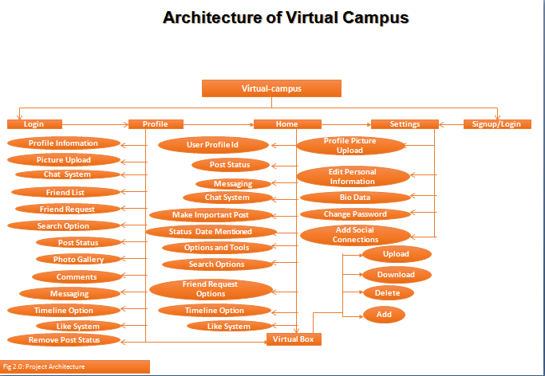

**Figure: 4.1.** Architecture of Virtual-campus system

### Usecase Digram of Virtual-campus System

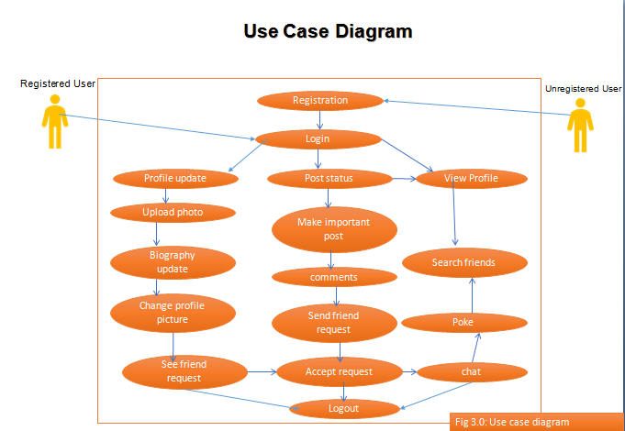

### Methodology of Virtual-campus System

Software development designed to define and there are many approaches. Let us develop and implement the use of the software. By using Waterfall model, V model, Incremental model, RAD model, agile model, Iterative model, and Spiral model are the development of software models & methods. Each cycle is to follow a life of software develop. So from the inside of the model we follow the waterfall model made us develop this risk management software does. This model has simple and easy to understand or use. This model is the coding and development testing. Then requirement of the implementation is against.

We have followed “Waterfall Model” to develop this software. Six steps of this model are shown below.

1. Requirement gathering and analysis
2. System Design
3. Implementation or coding
4. Testing
5. Deployment of system
6. Maintenance
7. **Requirement gathering and analysis:** Business requirements are gathered at this stage. The main focuses of this stage of the project managers and stakeholders. Manager, stake holders and users meeting was held to determine the requirements. We want to use the system. How can we use the system? What we should be input into the system. What information should be output by the system? This is the time to get answers to common questions in requirements gathering stage.
8. **System Design:** In this phase the system and software design is prepared from the requirement specifications which were studied in the first phase. System Design helps in specifying hardware and system requirements and also helps in defining overall system architecture.
9. **Implementation / Coding:** On receiving system design documents, the work is divided in modules/units and actual coding is started. In this phase the code is produced so it is the main focus for the developer. This is the longest phase of the software development life cycle.
10. **Testing:** After the code is developed it is tested against the requirements to make sure that the product is actually solving the needs addressed and gathered during the requirements phase. During this phase unit testing, integration testing, system testing, acceptance testing are done.
11. **Deployment of system:** After successful testing the product is delivered / deployed to the customer for their use.
12. **Maintenance:** Once when the customers starts using the developed system then the actual problems comes up and needs to be solved from time to time. This process where the care is taken for the developed product is known as maintenance.

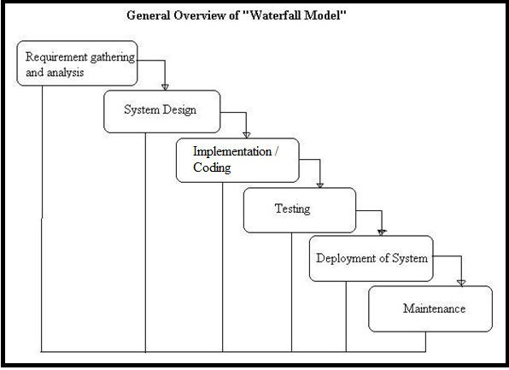

**Figure: 4.2.** Waterfall Model of architecture of Virtual-campus System

# Chapter – 5

**Design of Virtual-campus** **System**

In this chapter, we talk about the design of system. How we have design the system. We have a description of its part by part. The menu bar of the software includes (User Profile Information, Member directory, User home page, Virtual-campus drag and drop box, Share Important Posts, Search options of friend list, Change User Information/Settings and Logout) there. The inside of the list of User Profile Information (User bio-data, post Status, uploading file, photos, screenshot, software installation file, comment system, like and dislike system, chat system, search options of the friend List, connected to the social communication networks, timeline option). Post Status, uploading file, photos, screenshot, software installation file, comment system, like and dislike system, chat system, search options of the friend List, connected to the social communication networks, timeline option). The inside of the list of User Home Page (Post Status, uploading file, photos, screenshot, software installation file, comment system, like and dislike system, chat system, search options of the friend List, connected to the social communication networks, timeline option.). The inside of the list of Member Directory includes Friend Request Option. The inside of the list of Virtual-campus Drag and Drop Box (Uploading and downloading file, photos, screenshot, software installation file, audio and video file, delete file, photos, screenshot, software installation file, audio and video file from their own username). The inside of the list of Settings (Uploading Profile picture, modifying Profile picture, change user information, identity, bio-data, update password, add social communication networks). The design is described below.

### User Sign_in Page

### The first page of the Virtual-campus system is User Sign_in.

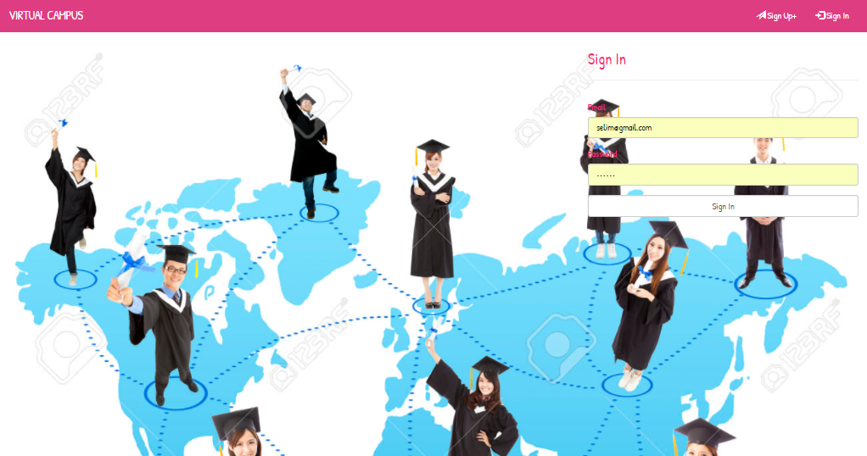

**Figure:** 5.1. User Sign_ in of this system

### User Registration or Sign_up Page

### This page of the Virtual-campus system is User Registration or Sign_up Page.

###### Here is a User Registration or Sign_up Page.



**Figure: 5.7** User Registration or Sign_up Page of Virtual-campus System.

### Sharing Important Posts page

###### This page is used to share important posts of user’s friend list.Here are sharing important posts of Virtual-campussystem.

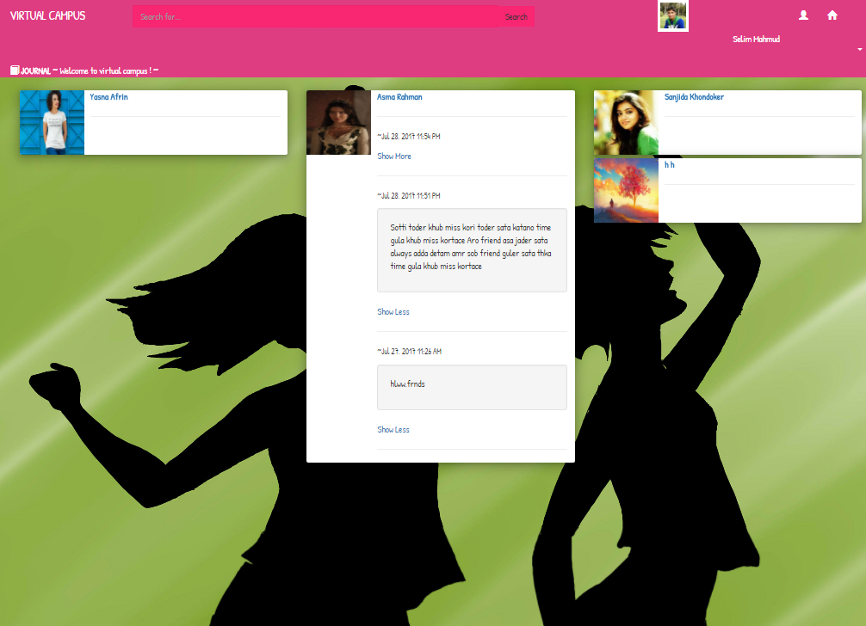

**Figure: 5.8** sharing important posts of Virtual-campussystem.

### User Profile Information

###### This page is used to User Profile Information.Here is User Profile Information of Virtual-campussystem.

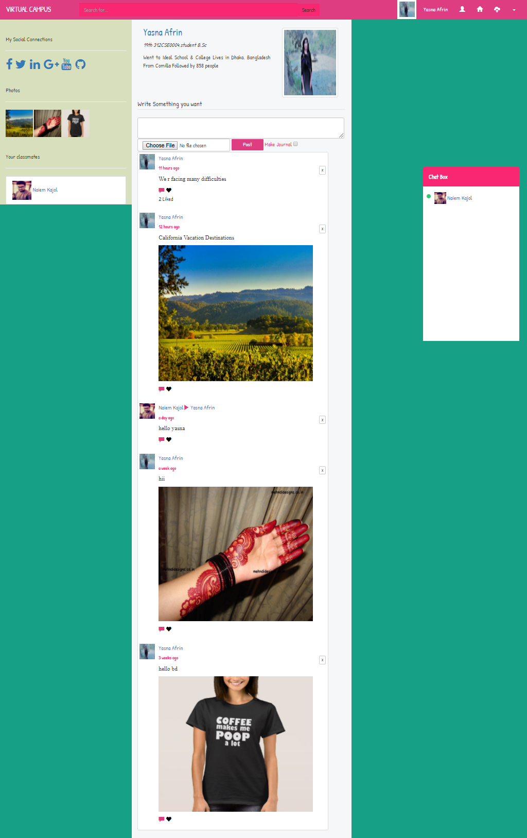

* 1. **Live conversation/chat System**

Here is live conversation/chat System.

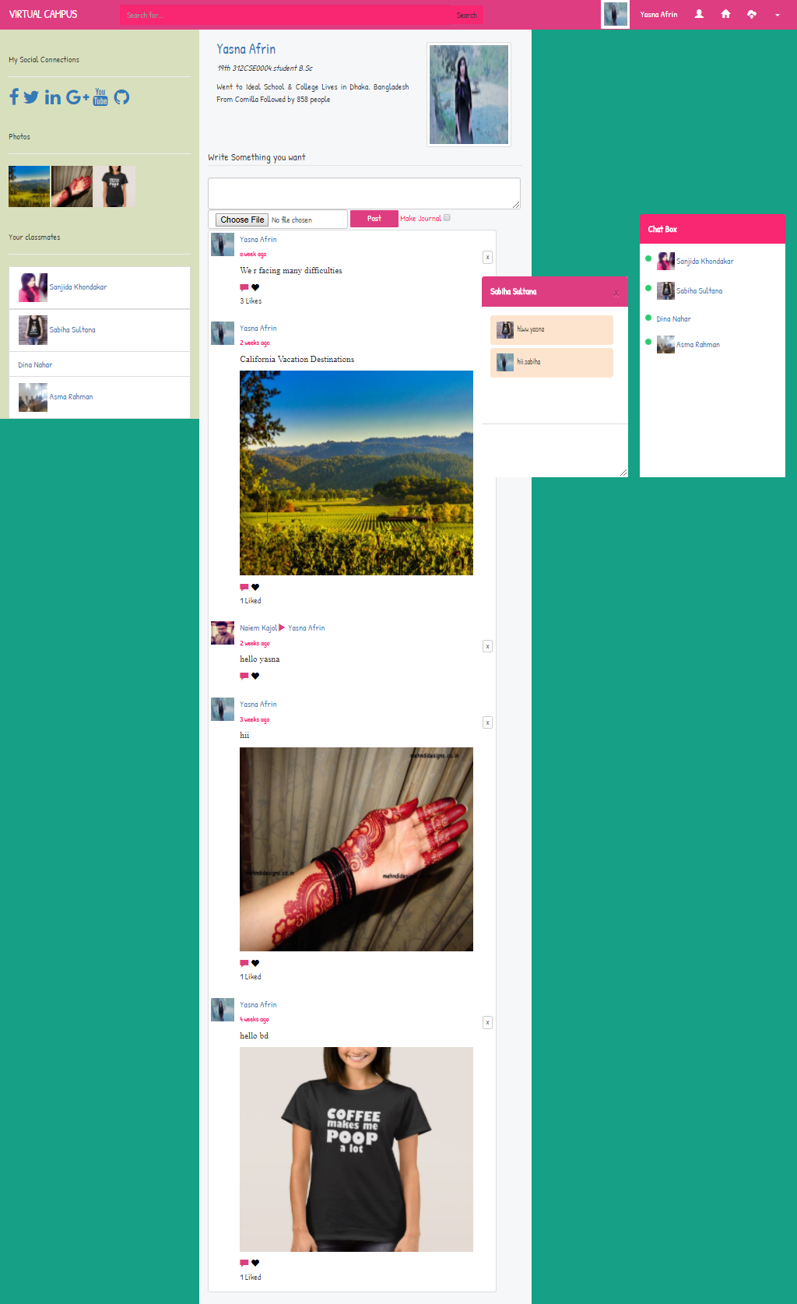

**5.6 Post System**

Here is Post System.User can delete his post status from his own ID.

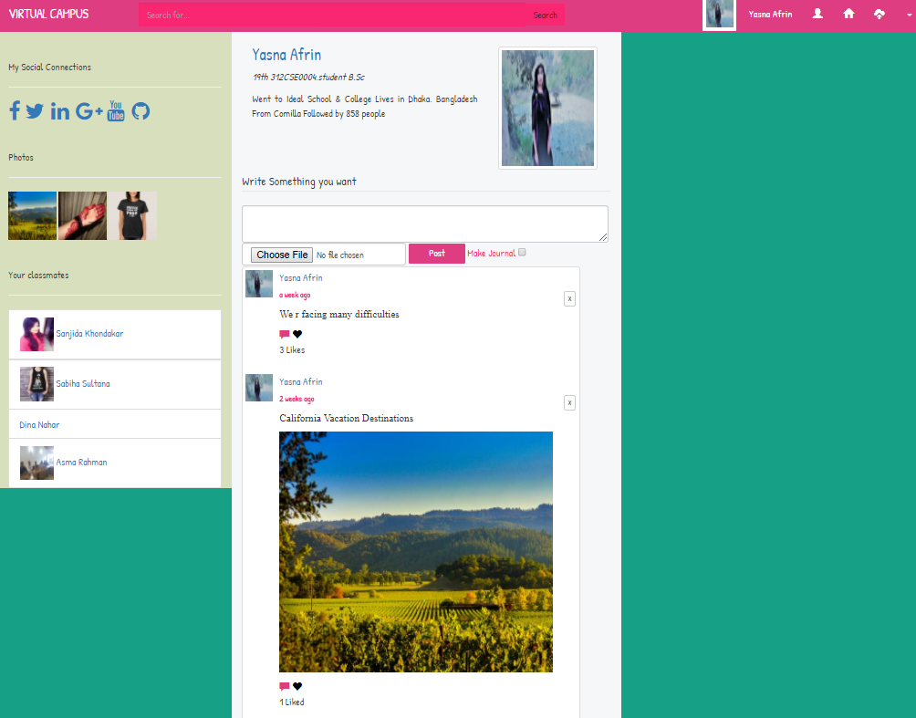

**5.7 Comment System**

Here is Comment System.

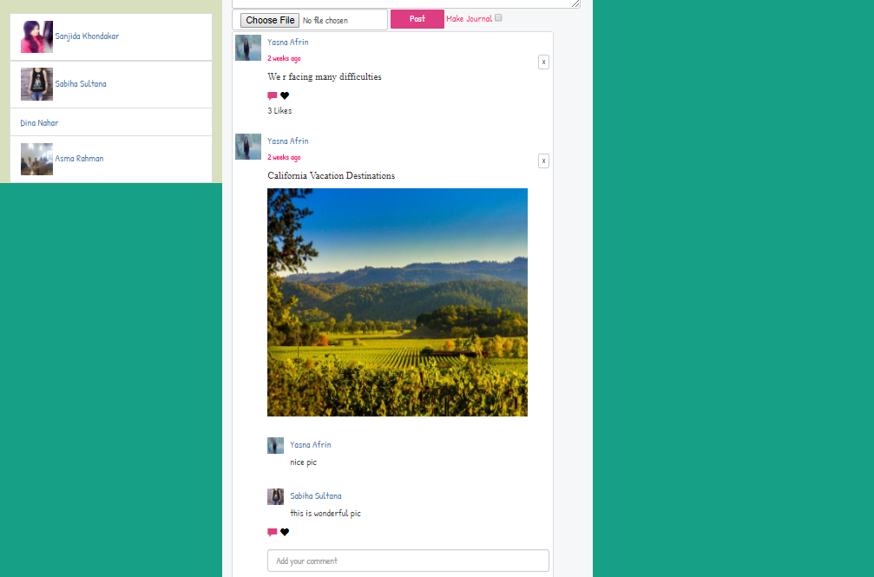

* 1. **Like System**

Here isLike System.

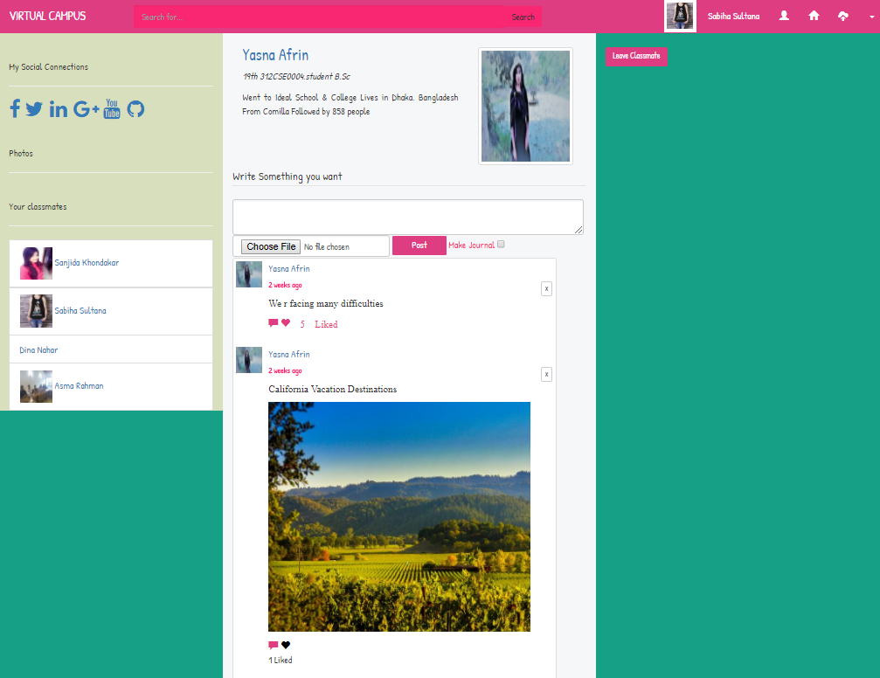

* 1. **Home Page**

Here is Home Page.Here is the post status of the user friend list.

.

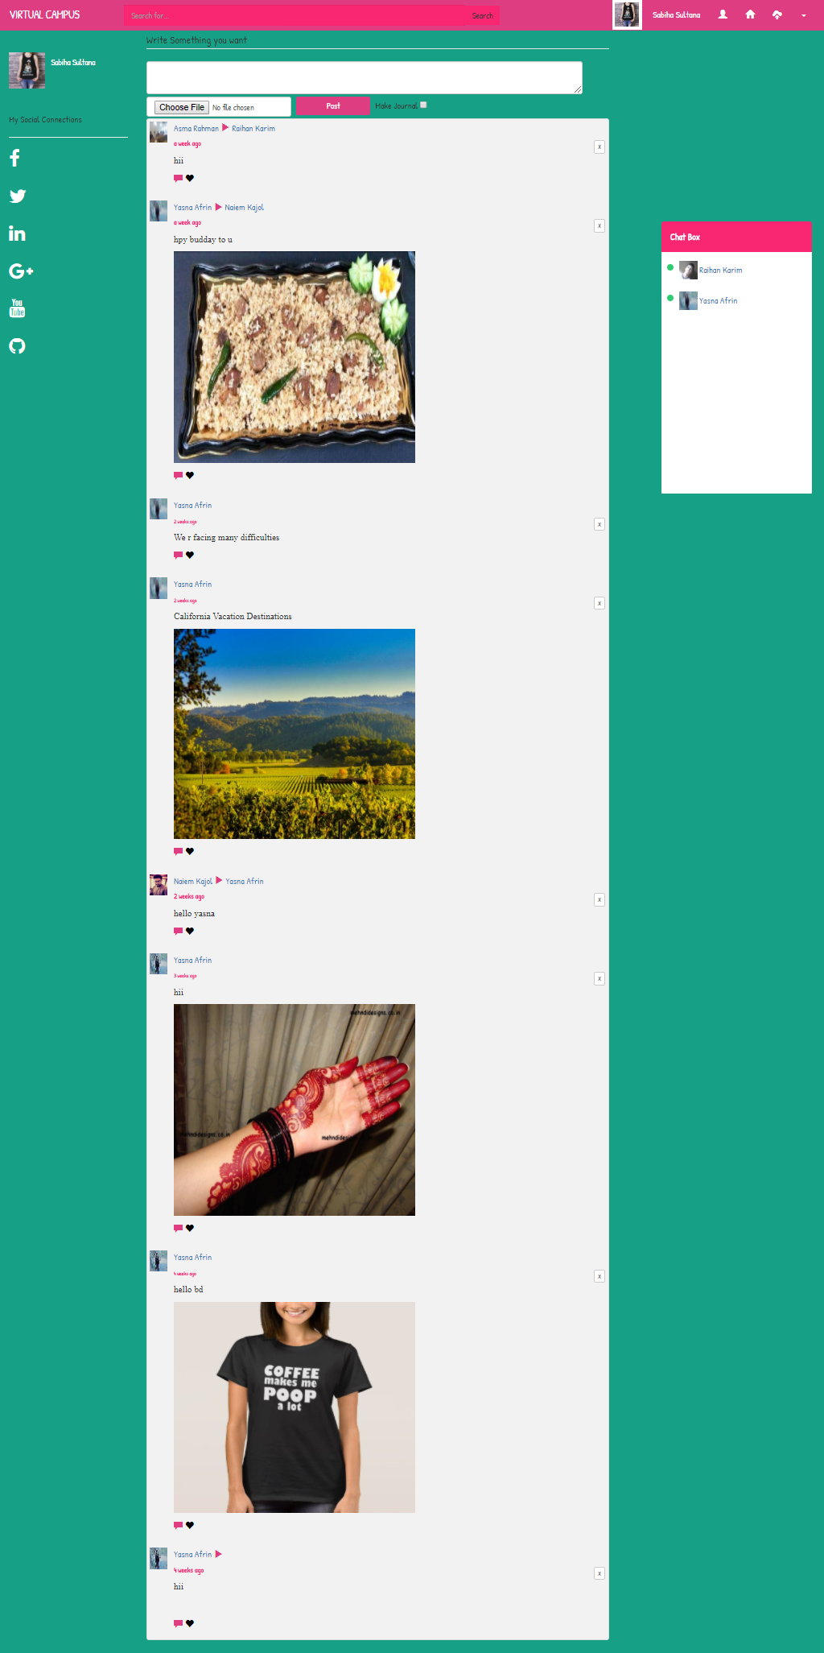

* 1. **Timeline Option**

Here is Timeline Option.

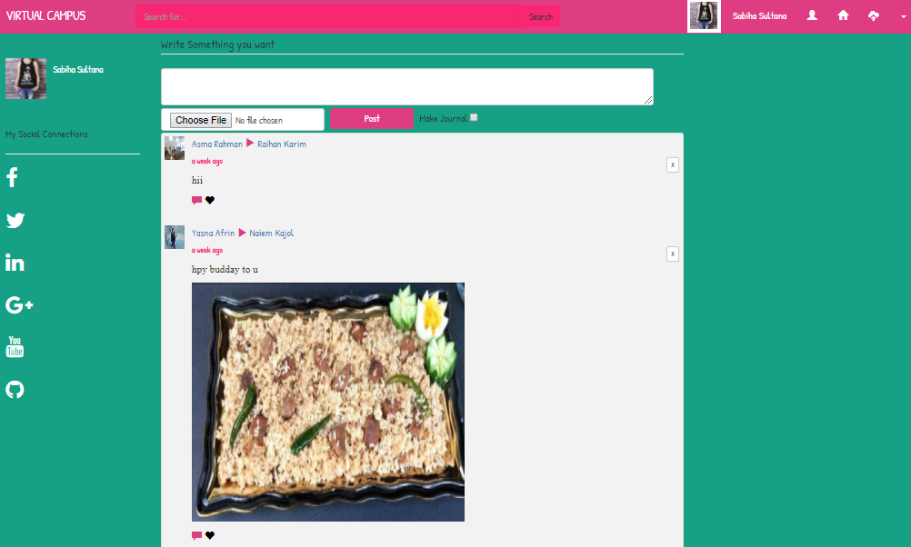

**5.11 Friend Request Option**

Here is Friend Request Option.

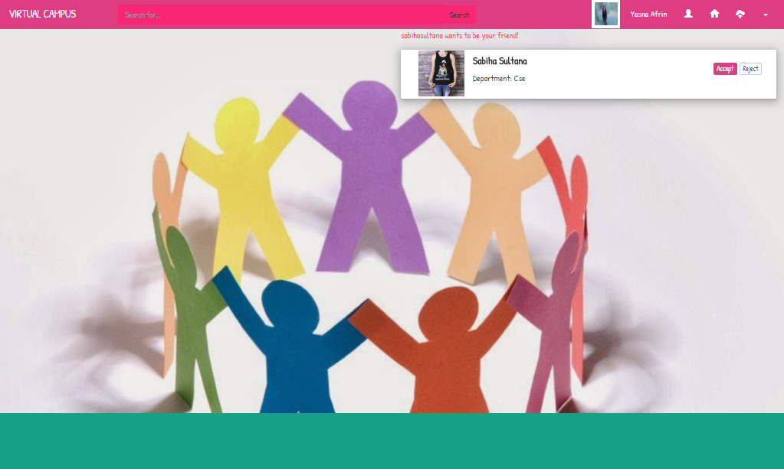

* 1. **Virtual-campus Drag and Drop box**

Here is Virtual-campus Drag and Drop box.User can upload and download file, screenshot, photo, audio, video file, software installation file etc.User can delete these from his own ID.

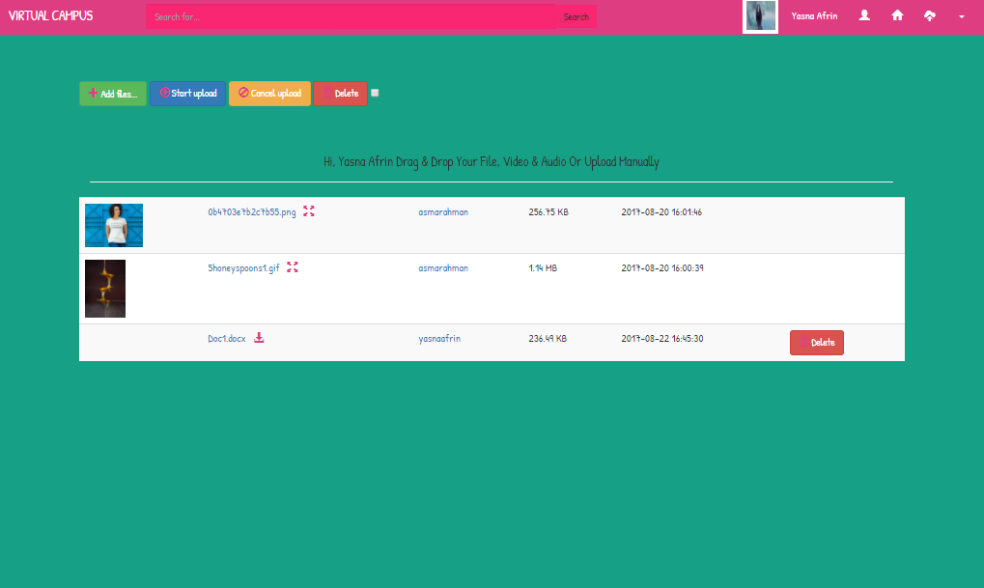

**5.13 Settings/Change User Information Option**

Here is Settings/Change User InformationOption.User can change user profile picture, identity, and password.

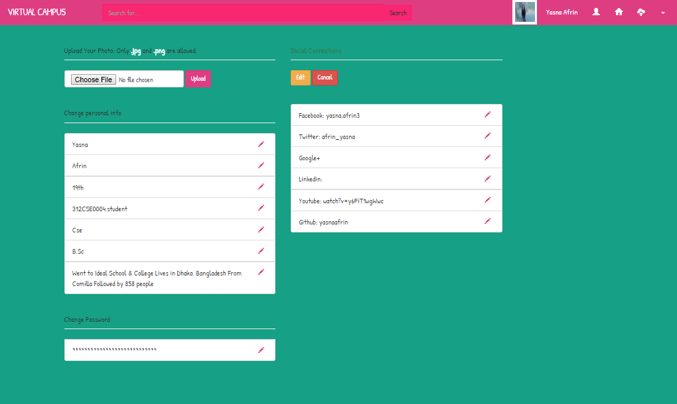

**5.14 Connection to the social Communication Sites**

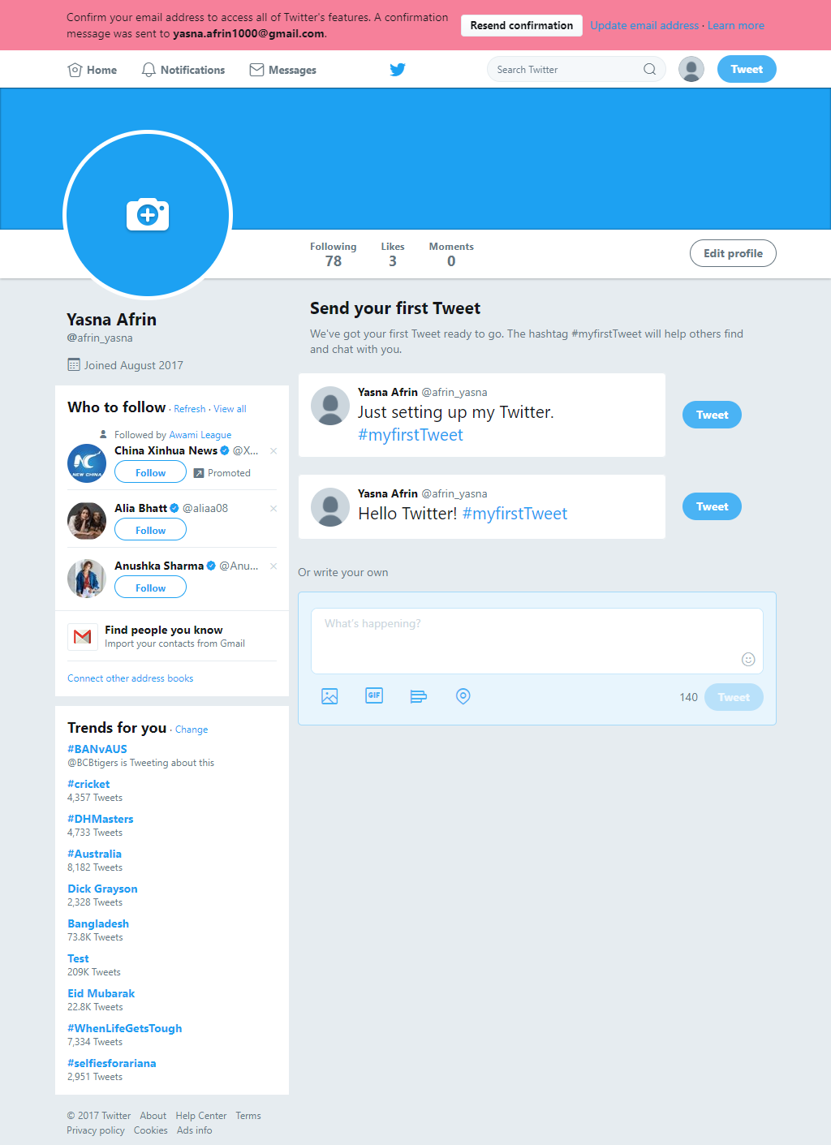Here is the Connection to the social Communication Sites such as Facebook, Twitter, Linkdin, Youtube, Github etc.If user write any username in the update option of the social communication sites of the settings option,it will directly connect to the social communication sites

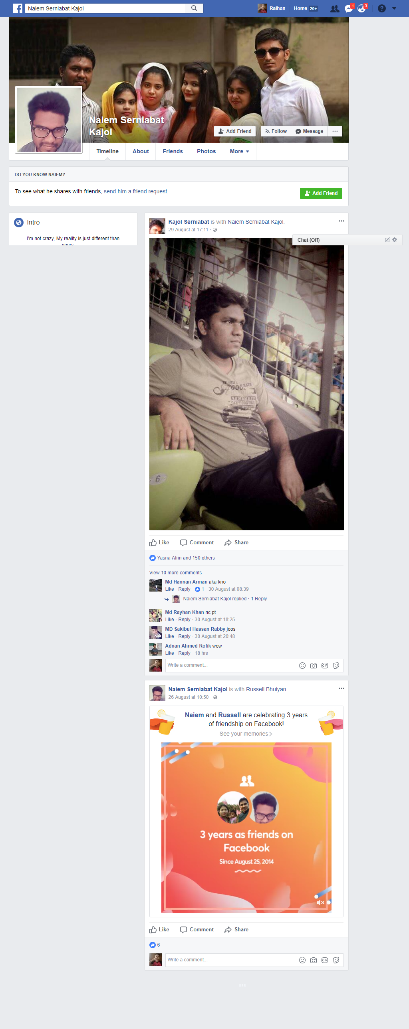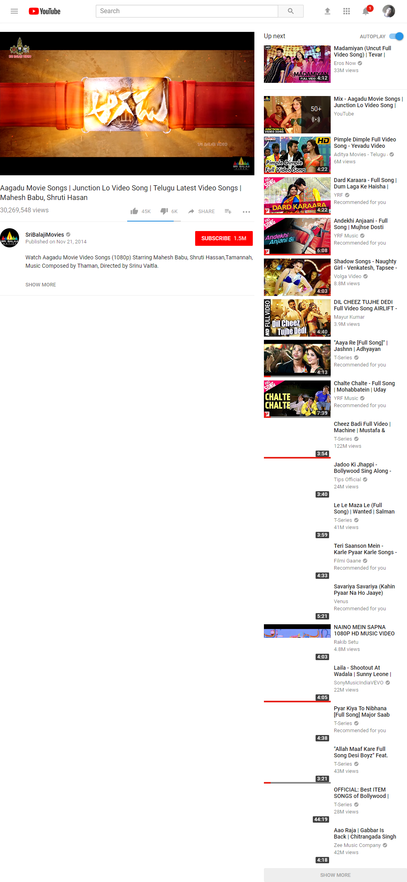.

**5.15 Database Design**

Database design is the process of producing a detailed data model of database. This data model contains all the needed logical and physical design choices and physical storage parameters needed to generate a design in a data definition language, which can then be used to create a database. A fully attributed data model contains detailed attributes for each entity. The term database design can be used to describe many different parts of the design of an overall database system. Principally, and most correctly, it can be thought of as the logical design of the base data structures used to store the data.

**5.15.1 Table List of Database and their requirements**

1. Chat-id, chat_from, chat_to, message, sent

2. Friend_request-id, user_from, user_to

3. Like_system-like_id, likes, liketext, post_id, username

4. Messages-id, user_from, user_to, msg_body, msg_date, opened

5. Posts-id, body, date_added, added_by, user_posted_to, status_pic, importance

6. Post_comments-comment_id, post_body, posted_by, posted_to, post_remove, post_id

7. Social_connections-social_id, username, facebook, twitter, linkedin, googleplus, youtube, github

8. Unlike_system-unlike_id, unlikes, unliketext, post_id, username

9. Users-id, fname, lname, username, email, password, gender, sign_up_date, activated, profile_picture, friend_array, batch, identy, department, program, bio_data, code_confirm

10. Virtual_box-id, name, size, type, URL, title, description, upload_date

**5.15.2 Relational Database**

A relational database is a collective set of multiple data sets organized by tables, records and columns. Relational database establish a well-defined relationship between database tables. Tables communicate and share information, which facilitates data searchability, organization and reporting. Relational database use Structured Query Language (SQL), which is a standard user application that provides an easy programming interface for database interaction.21 In general, the goal of relational-database design is to generate a set of relations schemes that allows us to store information without unnecessary redundancy, yet also allows us to retrace information easily. To determine whether a relation schema is in one of the normal, we need additional information about the real world enterprise that we are modeling with the database.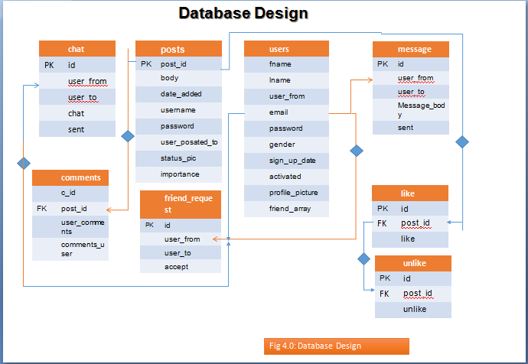

Figure 4.1: Database Schema Diagram

* + 1. **Entity Relationship Model**

The entity-relationship (E-R) data model is based on a perception of a real world that consists of a collection of basic objects, called entities and of relationships among these objects. That is a relationship is an association among several entities.

There are three basic notations that E-R data models employ:

Entity sets: The entity set is a set of entities of the same type, which are unique. Relations set: A relationship is an association among several entities.

Attributes: The properties of an attribute are known as attribute.

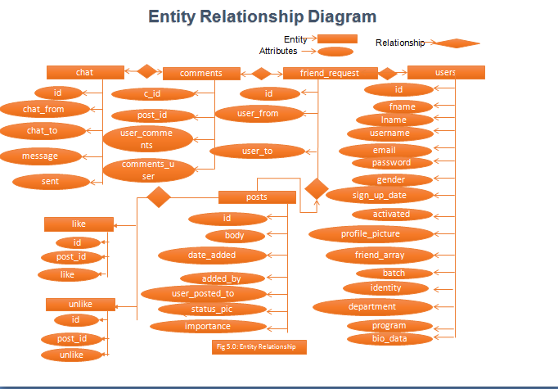

Figure 4.2: Entity Relationship Diagram

**Chapter – 6**

**Project Requirements**

Requirements stand for the need or want of an individual of a company. Requirements in human lives in a never ending procedure, every individual will remain only satisfied till the time something new or better is not available in the market, thus this demands never end and his requirements for something remains endless.

In the field of engineering, the term requirement is known as singular documented need of what a certain service of product should be. The term is very commonly known as Requirement phase.

* 1. **Language and Tools**

The language and tools that has been used to develop this project are as follows:

* + 1. **Languages**
       - HTML
       - Cascading Style Sheets (CSS)
       - My Sql
       - PHP
       - Java Script
       - Bootstrap
       - Jquery Language
       - Ajax Function
       - Sanitise Function
  1. **HTML**

HTML stands for Hyper Text Markup Language.

HTML is the language for describing the structure of Web pages. HTML gives authors the means to:

* Publish online documents with headings, label, form, and textboxes, submit button, tables, lists, photos, etc.
* Retrieve online information via hypertext links, at the click of a button.
* Design forms for conducting transactions with remote services, for use in searching for information, making reservations etc.
* Include grade sheet, tabulation sheet, final result publications, and other applications directly in their documents.
  1. **Cascading Style Sheets (CSS)**

CSS is the language for describing the presentation of Web pages, including colors, layout, and fonts. It allows one to adapt the presentation to different types of devices, such as large screens, small screens, or printers. CSS is independent of HTML and can be used with any XML-based markup language. The separation of HTML from CSS makes it easier to maintain sites, share style sheets across pages, and tailor pages to different environments. This is referred to as the separation of structure (or: content) from presentation.

**6.4 JavaScript**

JavaScript is the world's most popular programming language. It is the language for HTML, for the web, for servers, PCs, laptops, tablets, phones, and more. JavaScript is a Scripting Language.

* + - A scripting language is a lightweight programming language.
    - JavaScript is programming code that can be inserted into HTML pages.
    - JavaScript code can be executed by all modern web browsers.

**6.4.1 JavaScript is easy to learn**

JavaScript is the Netscape-developed object scripting language used in millions of web pages and server applications worldwide. JavaScript is a dynamic scripting language supporting Prototype based object construction. The basic syntax is intentionally similar to both Java and C++ to reduce the number of new concepts required to learn the language.

* + 1. **JQuery Language**

JQuery is a [cross-platform](https://en.wikipedia.org/wiki/Cross-platform) [JavaScript library](https://en.wikipedia.org/wiki/JavaScript_library) designed to simplify the [client-side scripting](https://en.wikipedia.org/wiki/Client-side_scripting) of [HTML](https://en.wikipedia.org/wiki/HTML).It is [free, open-source software](https://en.wikipedia.org/wiki/Free_and_open_source_software) using the permissive [MIT License](https://en.wikipedia.org/wiki/MIT_License). JQuery’s syntax is designed to make it easier to navigate a document, select [DOM](https://en.wikipedia.org/wiki/Document_Object_Model) elements, create [animations](https://en.wikipedia.org/wiki/Animation), handle [events](https://en.wikipedia.org/wiki/Event_(computing)), and develop [Ajax](https://en.wikipedia.org/wiki/Ajax_(programming)) applications.

* + 1. **Ajax Function**

A set of key/value pairs that configure the Ajax request. All settings are optional. A default can be set for any option with $.ajaxSetup(). See jQuery.ajax (settings) below for a complete list of all settings.

* 1. **MySql**

A MySQL database is a web hosting database that is used to store web site information like blog posts or user information. A Mysql database is the most popular type of relational database on the web today. This is partly because it is completely free but also very powerful. In basic terms, a MySql database is capable of storing any type of that you want. It will let you quickly store and retrieve information and multiple web site visitors can use it at one time.

MySql is a database server.

It is ideal for both small and large application. MySql Supports standard sql.

It compiles on a number of platforms. It is free to download and use.

* 1. **PHP**

PHP (recursive acronym for PHP: Hypertext Preprocessor) is a widely-used open source general-purpose scripting language that is especially suited for web development and can be embedded into HTML.

It is also helpful to think PHP in terms of what it can do for us. Php always us to:

* Reduce the time to create large web site.
* Create a customized user experience for visitors based on information that we have gathered from them.
* Open up thousands of possibilities for online tools.

**6.6.1 Why php?**

Php runs on different platforms (windows, Linux, UNIX, etc).

Php is compatible with almost all servers used today (apache, IIS, etc). Php free to download from the official php resources [www.php.net](http://www.php.net/).

Php is easy to learn and runs efficiently on the server side.

6.6.2 **Sanitize Function**

Sanitization modifies the input to ensure that it is valid.

**Summary**

Although mysql is not absolutely necessary to use php and php are wonderful complements to one another. Php is compatible with almost all servers used today. So, it already chose this project tools and platforms. And now we are ready to design the database and the web phases

**Chapter - 8**

**Conclusion**

From the researcher’s point of view, the whole action research process including the development of the E-resource, the blending together a ‘clear line sight of work’ approach with entrepreneurship, problem solving skills and embedded English and Math etc all encased in a visually appealing, stimulating and digitally authored learning object has resulted in a positive impact for teachers and students.

The positive impact of this project can potentially become a significant catalyst in helping to raise standards in teaching and learning, improve success rates on all courses, enhance learner satisfaction while studying in custody and helping them to prepare for life on the outside.

Exactly 100% of the work they completed on this project will be mapped against a range of modules for their OCR portfolios.

As per the recommendations in the FELTAG report, this action research project in E-Learning should pave the way for future tendering of bids for funding to develop a full range of E- resources that can also be published on the prison’s Virtual Campus (VC).

The E-Learning resource will also be submitted to Meganexus for verification before publication onto the VC.

**Appendix**

**Coding**………………………………………………………………………………………………………….…….40

**a. Common Page**….......................................................................................................40

1. Database Connect Page……………….………………………………………..….40

2. Header Page…………………………………………………………………....….40

3. Footer Page…..........................................................................................................43

4. Navigation……………………………………………………………………..….44

5. Sign_in page………….…………………………………………………………...47

6. Sign_up page……………………………………………………….……….........48

7. E-mail Notification System…………………………………………………….…53

8. Coding of Share Important Posts….........................................................................53

9. Settings page……………………………………………………………………...59

10. User Profile Page………………………………………………………………..77

11. Friend Request Option…………………………………………………………..86

12. Search Option…………………………………………………………………..91

13. Chat System….......................................................................................................91

14. Loading Chat System…......................................................................................96

16. Home page….......................................................................................................99

17. Sending Comment System…………………………………………………….106

18. Sending Post System….......................................................................................106

19. Like System…………….…………………………………………………..….107

20. Like Show…………….………………………………………………………….109

22. Virtual Drag and Drop Box….............................................110

23. Sign out page…................................................................114

**b. Reference** …..................................................................115

**Coding of Virtual-campus System**

This is to develop Virtual-campussystem software coding that has been given to it.This system is developed by HTML, CSS, Javascript, MySQL, jQuery Lamguage,ajax function and sanitize function. This coding is given below.

**Coding of Common Page**

* + 1. **Connect Database :** Sources code of Database Connect.

<?php ob_start(); ?>

<?php $db=mysqli_connect('localhost','tmuproje_yasna','qiOt}0_oaVwn','tmuproje_vc');

if (mysqli_connect_errno()) {

echo "Database connection failed with following errors".mysqli_connect_error();

die();

}

?>

**Header :** Sources code of Header.

<!-- <script src="//ajax.googleapis.com/ajax/libs/jquery/1.11.3/jquery.min.js"></script> -->

<!-- The jQuery UI widget factory, can be omitted if jQuery UI is already included -->

<script src="upload/js/vendor/jquery.ui.widget.js"></script>

<!-- The Templates plugin is included to render the upload/download listings -->

<script src="//blueimp.github.io/JavaScript-Templates/js/tmpl.min.js"></script>

<!-- The Load Image plugin is included for the preview images and image resizing functionality -->

<script src="//blueimp.github.io/JavaScript-Load-Image/js/load-image.all.min.js"></script>

<!-- The Canvas to Blob plugin is included for image resizing functionality -->

<script src="//blueimp.github.io/JavaScript-Canvas-to-Blob/js/canvas-to-blob.min.js"></script>

<!-- Bootstrap JS is not required, but included for the responsive demo navigation -->

<!-- <script src="//netdna.bootstrapcdn.com/bootstrap/3.2.0/js/bootstrap.min.js"></script> -->

<!-- blueimp Gallery script -->

<script src="//blueimp.github.io/Gallery/js/jquery.blueimp-gallery.min.js"></script>

<!-- The Iframe Transport is required for browsers without support for XHR file uploads -->

<script src="upload/js/jquery.iframe-transport.js"></script>

<!-- The basic File Upload plugin -->

<script src="upload/js/jquery.fileupload.js"></script>

<!-- The File Upload processing plugin -->

<script src="upload/js/jquery.fileupload-process.js"></script>

<!-- The File Upload image preview & resize plugin -->

<script src="upload/js/jquery.fileupload-image.js"></script>

<!-- The File Upload audio preview plugin -->

<script src="upload/js/jquery.fileupload-audio.js"></script>

<!-- The File Upload video preview plugin -->

<script src="upload/js/jquery.fileupload-video.js"></script>

<!DOCTYPE html>

<?php session_start();?>

<html lang="en">

<head>

<meta charset="utf-8">

<meta http-equiv="X-UA-Compatible" content="IE=edge">

<meta name="viewport" content="width=device-width, initial-scale=1">

<title>Virtual Campus</title>

<link rel="stylesheet" href="css/style.css">

<link rel="stylesheet" href="css/bootstrap.min.css">

<link rel="stylesheet" href="css/chat.css">

<link rel="stylesheet" href="css/swipebox.css">

<link rel="stylesheet" href="https://maxcdn.bootstrapcdn.com/font-awesome/4.7.0/css/font-awesome.min.css">

<link href="https://fonts.googleapis.com/css?family=Lobster+Two|Satisfy" rel="stylesheet">

<link href="https://fonts.googleapis.com/css?family=Lobster+Two|Patrick+Hand|Satisfy" rel="stylesheet">

<!-- Bootstrap styles -->

<!-- <link rel="stylesheet" href="//netdna.bootstrapcdn.com/bootstrap/3.2.0/css/bootstrap.min.css"> -->

<!-- Generic page styles -->

<!-- <link rel="stylesheet" href="upload/css/style.css"> -->

<!-- blueimp Gallery styles -->

<link rel="stylesheet" href="//blueimp.github.io/Gallery/css/blueimp-gallery.min.css">

<!-- CSS to style the file input field as button and adjust the Bootstrap progress bars -->

<link rel="stylesheet" href="upload/css/jquery.fileupload.css">

<link rel="stylesheet" href="upload/css/jquery.fileupload-ui.css">

<!-- CSS adjustments for browsers with JavaScript disabled -->

<noscript><link rel="stylesheet" href="upload/css/jquery.fileupload-noscript.css"></noscript>

<noscript><link rel="stylesheet" href="upload/css/jquery.fileupload-ui-noscript.css"></noscript>

<!-- <link rel="stylesheet" href="css/screen_ie.css">

<link rel="stylesheet" href="css/screen.css"> -->

<!-- jQuery (necessary for Bootstrap's JavaScript plugins) -->

<script src="js/jquery-1.10.2.min.js"></script>

<!-- Include all compiled plugins (below), or include individual files as needed -->

<script src="js/bootstrap.min.js"></script>

<script type="text/javascript" src="js/script.js"></script>

<script type="text/javascript" src="js/chat.js"></script>

<script type="text/javascript" src="js/dropzone.js"></script>

<script src="js/jquery.swipebox.js"></script>

<!-- HTML5 shim and Respond.js for IE8 support of HTML5 elements and media queries -->

<!-- WARNING: Respond.js doesn't work if you view the page via file:// -->

<!--[if lt IE 9]>

<script src="https://oss.maxcdn.com/html5shiv/3.7.3/html5shiv.min.js"></script>

<script src="https://oss.maxcdn.com/respond/1.4.2/respond.min.js"></script>

<![endif]-->

</head>

<?php

if(isset($_SESSION["username"])){

$user = $_SESSION["username"];

}

else{

// header('location:sign_in.php','_self');

// exit();

}

?>

<?php $getName="SELECT * FROM users WHERE username='$user'";

$runName=$db->query($getName);

while($fetchName=mysqli_fetch_assoc($runName)){

extract($fetchName);

}?>

<body>

* + 1. **Footer :** Sources code of Footer.

<!-- The File Upload validation plugin -->

<script src="upload/js/jquery.fileupload-validate.js"></script>

<!-- The File Upload user interface plugin -->

<script src="upload/js/jquery.fileupload-ui.js"></script>

<!-- The main application script -->

<script src="upload/js/main.js"></script>

<!-- The XDomainRequest Transport is included for cross-domain file deletion for IE 8 and IE 9 -->

<!--[if (gte IE 8)&(lt IE 10)]>

<script src="js/cors/jquery.xdr-transport.js"></script>

<![endif]-->

</body>

</html>

<?php ob_end_flush(); ?>

**3. Navigation Page :** Sources code ofNavigation Page.

<!-- this is navigation area start -->

<script type="text/javascript">

$(document).ready(function(){

$('#search_text').keyup(function(){

var search_text=document.getElementById('search_text');

var txt=$(this).val();

if (txt=='' ) {

$('#result').html('');

}

else{

$('#result').html('');

$.ajax({

url:'search.php',

method:'post',

data:{search:txt},

success:function(data){

$('#result').html(data);

}

})

}

})

})

</script>

<nav class="navbar navbar-default">

<div class="container-fluid">

<!-- Brand and toggle get grouped for better mobile display -->

<div class="navbar-header">

<button type="button" class="navbar-toggle collapsed" data-toggle="collapse" data-target="#bs-example-navbar-collapse-1" aria-expanded="false">

<span class="sr-only">Toggle navigation</span>

<span class="icon-bar"></span>

<span class="icon-bar"></span>

<span class="icon-bar"></span>

</button>

<a class="navbar-brand text-center" href="index.php" style="font-family: 'Patrick Hand', cursive;">VIRTUAL CAMPUS</a>

</div>

<!-- Collect the nav links, forms, and other content for toggling -->

<div class="collapse navbar-collapse" id="bs-example-navbar-collapse-1">

<ul class="nav navbar-nav">

</ul>

<?php if (isset($_SESSION['username'])): ?>

<div class="col-lg-6 form-fix">

<div class="input-group">

<input type="text" id="search_text" name="search" class="form-control custom-primary-bg custom-form-border" placeholder="Search for...">

<span class="input-group-btn">

<button class="btn btn-default custom-primary-bg custom-form-border" type="button"><span class="glyphicon-glyphicon-search">Search</span></button>

</span>

</div><!-- /input-group -->

</div><!-- /.col-lg-6 -->

<?php endif; ?>

<ul class="nav navbar-nav navbar-right">

<?php if (isset($_SESSION['username'])): ?>

<?php

$select_post=" SELECT profile_picture FROM users WHERE username='$username' ";

$run_post=$db->query($select_post);

while($row = mysqli_fetch_array($run_post)):

extract($row);

$post_image=$row['profile_picture'];

?>

<li class="active"><a href="<?=$user;?>" style="padding:4.5px !important;"><img src="./images/<?php echo $row['profile_picture'];?>" style="width:40px;height:40px;" alt=""> <span class="sr-only">(current)</span></a></li>

<?php endwhile; ?>

<li><a href="<?=$user;?>"><span style="color:#fff !important;" class="glyphicon glyphicon-"></span> <?=$fname;?> <?=$lname;?></a></li>

<li><a href="friend_request.php"><span style="color:#fff !important;" class="glyphicon glyphicon-user"></span></a></li>

<li><a href="home.php"><span style="color:#fff !important;" class="glyphicon glyphicon-home"></span></a></li>

<!-- <li><a href="#"><span style="color:#fff !important;" class="glyphicon glyphicon-envelope"></span><?php //if (isset($message)): ?>

<span style="color:red;">1</span>

<?php //endif ?></a></li> -->

<li><a href="virtual_box.php"><span style="color:#fff !important;" class="glyphicon glyphicon-cloud-upload"></span></a></li>

<li class="dropdown">

<a href="#" class="dropdown-toggle" data-toggle="dropdown" role="button" aria-haspopup="true" aria-expanded="false"><span class="caret"></span></a>

<ul class="dropdown-menu">

<li><a href="<?=$username;?>" style="margin:10px;"><span class="glyphicon glyphicon-user"></span> Profile</a></li>

<li><a href="settings.php"><span class="glyphicon glyphicon-cog"></span> Settings</a></li>

<li><a href="friend_request.php"><span class="glyphicon glyphicon-book"></span> Friend Request</a></li>

<!-- <li><a href="customer/index.php?myorder"><span class="glyphicon glyphicon-question-sign"></span> FQA</a></li>

<li><a href="customer/index.php?myorder"><span class="glyphicon glyphicon-send"></span> Submit Query</a></li>

<li><a href="customer/index.php?myorder"><span class="glyphicon glyphicon-exclamation-sign"></span> Help</a></li> -->

<li role="separator" class="divider"></li>

<li><a href="sign_out.php"><span class="glyphicon glyphicon-off"></span> Sign Out</a></li>

</ul>

</li>

<?php else: ?>

<li><a href="sign_up.php"><span style="color:#fff !important;"></span></a></li>

<li><a href="sign_in.php"><span style="color:#fff !important;"></span></a></li>

<?php endif; ?>

</ul>

</div><!-- /.navbar-collapse -->

</div><!-- /.container-fluid -->

</nav>

<!-- Navigation end here -->

<div id="result" style="z-index: 1;position: absolute;" class="col-md-5 col-md-offset-2"></div>

**4. Sign_in Page** : Sources code ofSign_inPage.

1. <?php include 'core/dbc.php';?>
2. <?php include 'includes/header.php'; ?>
3. <?php include 'includes/navigation.php'; ?>
4. <?php if (isset($_SESSION['username'])) {
5. echo "<script>window.open('index.php','_self');</script>";
6. } ?>
7. <div class="container-fluid custom-success" style="background: url(img/signup.jpg)no-repeat !important;background-size: 100% !important;height:670px; width:100%!important;">
8. <div class="row">
9. <div class="col-md-6"></div>
10. <div class="col-md-4 pull-right">
11. <?php
12. $email=((isset($_POST['email']))?sanitize($_POST['email']):'');
13. // $email=trim($email);
14. //$password=123456;
15. $password=((isset($_POST['password']))?sanitize($_POST['password']):'');
16. $passwordMd5=md5($password);
17. //$hashed=password_hash($password, PASSWORD_DEFAULT);
18. $errors=array();
19. // Form validation
20. if ($_POST) {
21. if (empty($_POST['email']) || empty($_POST['password'])) {
22. $errors[]='Email or password is missing';
23. }
24. if (!filter_var($email, FILTER_VALIDATE_EMAIL)) {
25. $errors[]='You must enter a valid email';
26. }
27. // if (strlen($password)<6) {
28. // $errors[]='Password must be at least 6 characters';
29. // }
30. $query=$db->query("SELECT * FROM users WHERE email='$email' AND password='$passwordMd5' AND code_confirm>0 ");
31. $user=mysqli_fetch_assoc($query);
32. $userCount=mysqli_num_rows($query);
33. // echo $user['password'];
34. if ($user['code_confirm']==0 || empty($user['code_confirm'])) {
35. $errors[]='Your account is not activated. Please check your email and submit your activation code!';
36. }
37. if ($userCount<1) {
38. $errors[]='That email does not exit!';
39. }
40. if ($passwordMd5!=$user['password']) {
41. $errors[]="Your password does not match";
42. }
43. // if (!password_verify($password, $user['password'])) {
44. // $errors[]='The password doest not match!';
45. // }
46. if (!empty($errors)) {
47. echo display_errors($errors);
48. }
49. else{
50. $username=$user['username'];
51. echo "<script>alert('Sign In Successfull')</script>";
52. // echo $username=$user['username'];
53. login($username);
54. **Sign_up Page**: Sources code ofSign_upPage.

<?php include 'core/dbc.php';?>

<?php include 'includes/header.php'; ?>

<?php include 'includes/navigation.php'; ?>

<div class="container-fluid custom-success" style="background: url(img/Verimli-Ders-Çalışmanın-Teknikleri.jpg)no-repeat !important;background-size: 100% !important;height:670px; width:100%!important;">

<div class="row">

<div class="col-md-7">

<h3 class="pull-right">Join with Virtual Campus.<br><br> It's Always Free!</h3>

<!-- <h3 class="pull-right">It's Always Free!</h3> -->

</div>

<div class="col-md-4 pull-right">

<div class="panel-heading"><h3>Sign Up</h3><hr></div>

<?php

$fn=((isset($_POST['fname']))?sanitize($_POST['fname']):'');

$ln=((isset($_POST['lname']))?sanitize($_POST['lname']):'');

$email=((isset($_POST['email']))?sanitize($_POST['email']):'');

$email2=((isset($_POST['email2']))?sanitize($_POST['email2']):'');

$password=((isset($_POST['password']))?sanitize($_POST['password']):'');

$gn=((isset($_POST['gender']))?sanitize($_POST['gender']):'');

$un=strtolower($fn.$ln);

$batch="";

$identy="";

$department="";

$program="";

$bio_data="";

$code=0;

$d = date("Y-m-d");

$post_image = "";

$friend_array= "";

$u_check = "";

$confirm_code=rand();

$msg=

'<h2>Hi ' .$fn.' '.$ln."</h2>"."<br>"

.'Email : ' .$email."<br><br>"

.'Confirmation Code : ' .$confirm_code."<br><br>"

.'Username : ' .$un."<br><br>"

."Thank you for joining our Virtual Campus"."<br><br>"

."<td><a href='www.tmuproject.com/virtual-campus/confirm_email.php?user=$un'>Confirm Your email address</a></td>"."<br><br>"

.'If above link does not work then copy the link below and paste it on browser'.'<br><br>'

.'Confirmation Link : '.'<a href="#">www.tmuproject.com/virtual-campus/confirm_email.php?user='.$un.'</a>';

$headers = 'MIME-Version: 1.0' . "\r\n";

$headers .= 'Content-type: text/html; charset=iso-8859-1' . "\r\n";

if ($_POST) {

$emailQuery=$db->query("SELECT * FROM users WHERE email='$email'");

$emailCount=mysqli_num_rows($emailQuery);

if ($emailCount !=0) {

$errors[]='This Email Already exist!';

}

$required=array('fname', 'lname','email','email2', 'password','gender');

foreach($required as $f){

if (empty($_POST[$f])) {

$errors[]='Please fill out the all fields!';

break;

}

}

if (strlen($password)<6) {

$errors[]='Your provided password must at least 6 characters!';

}

if ($email!=$email2) {

$errors[]='Your email does not match!';

}

if (!filter_var($email, FILTER_VALIDATE_EMAIL)) {

$errors[]='You must enter a valid email!';

}

// $email_domain = preg_replace('/^.+?@/', '', $email).'.';

// if(!checkdnsrr($email_domain, 'MX') && !checkdnsrr($email_domain, 'A')){

// $errors[]='Your Email is not valid!';

// }

// if (mail($email,'Virtual Campus User Registration Notification', $msg)) {

// }else{

// $errors[]='Invalid mail!';

// }

if (!empty($errors)) {

echo display_errors($errors);

}

else{

// add user to database

$pmd5=md5($password);

$userData=$db->query("INSERT INTO users VALUES('','$fn','$ln','$un','$email','$pmd5','$gn','$d','0','$post_image', '$friend_array','$batch','$identy','$department','$program','$bio_data','$code') ");

if ($userData) {

$_SESSION['success_flash']='<span style="color:green;">Your account is created! you can sign in now<span>';

echo "<script>alert('Sign Up Successfull. Sign in please!');</script>";

echo "<script>window.open('sign_in.php','_self');</script>";

mail($email,'New user registration Successful',$msg, $headers);

}

}

}

?>

<form action="" class="form" method="post">

<div class="form-group">

<label for="fname">First Name</label>

<input type="text" name="fname" class="form-control">

</div>

<div class="form-group">

<label for="lname">Last Name</label>

<input type="text" name="lname" class="form-control">

</div>

<div class="form-group">

<input type="hidden" name="username" value="<?=$username;?>" class="form-control">

</div>

<div class="form-group">

<label for="email">Email</label>

<input type="text" name="email" class="form-control">

</div>

<div class="form-group">

<label for="email2">Confirm Email</label>

<input type="text" name="email2" class="form-control">

</div>

<div class="form-group">

<label for="password">Password</label>

<input type="password" name="password" class="form-control">

</div>

<div class="form-inline">

<label for="confirm">Male</label>

<input type="radio" name="gender" value="male" class="form-control">

<label for="confirm">Female</label>

<input type="radio" name="gender" value="female" class="form-control">

</div>

<div class="form-group">

<input type="submit" name="reg" value="Sign Up" class="form-control">

</div>

</form>

<p>Already have an account? <a href="sign_in.php"> Signin here</a> </p>

</div>

</div>

</div>

<?php include 'includes/footer.php'; ?>

**E-mail Notification System**: Sources code ofE-mail Notification System.

<?php include 'core/dbc.php';?>

<form action="" method="post">

<input type="text" name="code_confirm"><input type="submit" name="code_sb" value="Confirm">

</form>

<?php

if (isset($_POST['code_sb'])) {

$user=$_GET['user'];

$code=$_POST['code_confirm'];

$sql="UPDATE users SET code_confirm='$code' WHERE username='$user'";

$qry=$db->query($sql);

if ($qry) {

echo "<p>Your email address successfully confirmed. You can login now <a href='sign_in.php'>here</a></p>";

}

else{

echo "Email confirmation failed!";

}

**Coding of Share Important Posts**

**Share Important Posts:** Sources code of Share Important Posts.

<?php include 'core/dbc.php';?>

<?php include s'includes/header.php'; ?>

<?php include 'includes/navigation.php'; ?>

<?php if (!isset($_SESSION["username"])) {

header('location:sign_in.php','_self');

} ?>

<div class="container-fluid">

<div class="row">

<div class="col-md-12 c-success">

<span class="glyphicon glyphicon-book" style="color:#fff !important;"></span><strong> JOURNAL ~</strong> <span>Welcome to virtual campus !</span><strong> ~</strong>

</div>

<div class="col-md-12" style="background: url(img/Alienate-a-Toxic-Friend-from-Your-Friend-Group-Step-7.jpg); background-size:100%; min-height: 850px;"><br>

<?php

$fArray="";

$countF="";

$fArray12="";

$friendQ=$db->query("SELECT friend_array FROM users WHERE username='$username'");

$fRow=mysqli_fetch_assoc($friendQ);

$fArray=$fRow['friend_array'];

if ($fArray!="") {

$fArray=explode(",", $fArray);

$countF=count($fArray);

$fArray12=array_slice($fArray, 0, 12);

}

if ($countF!= 0):

foreach ($fArray as $key => $value):

$i++;

$getFriendQuery = $db->query("SELECT * FROM users WHERE username='$value'");

while($getFriendRow = mysqli_fetch_assoc($getFriendQuery)):

?>

<div class="col-md-4">

<div class="media custom-shadow">

<div class="media-left">

<?php

$friendUsername = $getFriendRow['username'];

$friendfname = $getFriendRow['fname'];

$friendlname = $getFriendRow['lname'];

$friendsProfile = $getFriendRow['profile_picture'];

// var_dump($friendsProfile);

//if ($friendsProfile==""):?>

<?php if (empty($friendsProfile)): ?>

<?php else: ?>

<a href='<?=$friendUsername;?>'><img style='width:100px; height:100px;' src='./images/<?=$friendsProfile;?>' alt='<?=$friendUsername."'s Profile!;"?> title='<?=$friendUsername."'s Profile!";?>'>

</a>

<?php endif ?>

</div>

<div class="media-body">

<strong class="media-heading" ><a href="<?=$friendUsername;?>"><?=$friendfname;?> <?=$friendlname; ?></a></strong>

<?php //endif;?>

<?php

$getposts =$db->query("SELECT * FROM posts WHERE user_posted_to = '$value' AND importance=1 ORDER BY id DESC ") or die(mysqli_error());

while ($row = mysqli_fetch_assoc($getposts)):

$id = $row['id'];

$body = $row['body'];

$date_added = $row['date_added'];

$added_by = $row['added_by'];

$user_posted_to = $row['user_posted_to'];

$importance=$row['importance'];

?>

<hr><p><small>~<?=pretty_date($date_added);?></small></p>

<div class="collapse" id="<?=$id;?>">

<div class="well">

<p><?php echo $body; ?></p>

</div>

</div>

<p><a class="SeeMore2" role="button" data-toggle="collapse" href="#<?=$id;?>" aria-expanded="false" aria-controls="<?=$id;?>">Show More</a>

<?php endwhile; ?></p><hr>

</div>

</div>

</div>

<?php endwhile; ?>

<?php endforeach; ?>

<?php else:?>

<?php endif;?>

</div>

</div>

</div>

<script type="text/javascript">

$(document).ready(function(){

$('.SeeMore2').click(function(){

var $this = $(this);

$this.toggleClass('SeeMore2');

if($this.hasClass('SeeMore2')){

$this.text('Show More');

} else {

$this.text('Show Less');

}

});

})

</script>

<?php include 'includes/footer.php'; ?>

1. **Settings Page**: Sources code of Settings Page.

<?php include 'core/dbc.php';?>

<?php include 'includes/header.php'; ?>

<?php include 'includes/navigation.php'; ?>

<?php

if ($user) {

}

else{

die("You must logged in!");

}

?>

<div class="container-fluid">

<div class="row">

<!-- upload profile -->

<div class="col-md-4 col-md-offset-1">

<div class="page-header">Upload Your Photo: Only <strong style="color:#fff;">.jpg</strong> and <strong style="color:#fff;">.png</strong> are allowed.</div>

<?php

// new code

if (isset($_POST['upload_image'])) {

if ($_FILES['image_file']['name']!=''){

$allowedEx=array("jpg","png");

$extension=explode('.', $_FILES['image_file']['name']);

$ext=end($extension);

// $ext =explode('.', $_FILES['image_file']['name']);

// $extension = strtolower(array_pop($ext));

// $fileName = array_shift($ext);

if (in_array($ext, $allowedEx)) {

if ($_FILES['image_file']['size']<500000) {

$name=md5(rand()).'.'.$ext;

$path="images/".$name;

move_uploaded_file($_FILES['image_file']['tmp_name'], $path);

$insert_query="UPDATE users SET profile_picture ='$name' WHERE username='$user'";

$db->query($insert_query);

header('location:'.$username.'?file_name='.$name.'');

}

else{

echo "<script>alert('Image too large')</script>";

}

}

else{

echo "<script>alert('Image is invalid')</script>";

}

}

else{

echo "<script>alert('Please select a image')</script>";

}

}

// new code image upload end

// if (isset($_POST['upload'])) {

// $chars = "abcdefghijklmnopqrstuvwxyzABCDEFGHIJKLMNOPQRSTUVWXYZ123456789";

// $rand_dir_name = substr(str_shuffle($chars),0,15);

// mkdir("images/$rand_dir_name");

// $post_image =$_FILES['file']['name'];

// $allowedExts = array("gif", "jpeg", "jpg", "png");

// $extension = end(explode(".", $_FILES["file"]["name"]));

// if ((($_FILES["file"]["type"] == "image/gif")

// || ($_FILES["file"]["type"] == "image/jpeg")

// || ($_FILES["file"]["type"] == "image/jpg")

// || ($_FILES["file"]["type"] == "image/png"))

// && ($_FILES["file"]["size"] < 20000)

// && in_array($extension, $allowedExts))

// if ($post_image=="") {

// echo "<p class='alert-danger'>You did not select any photo</p>";

// }else{

// $post_image =$_FILES['file']['name'];

// $image_tmp=$_FILES['file']['tmp_name'];

// move_uploaded_file($image_tmp,"./images/$post_image");

// $insert_query="UPDATE users SET profile_picture ='$post_image' WHERE username='$user'";

// }

// if ($db->query($insert_query))

// {

// echo "<p class='alert-success'>

// Profile picture upload successfully! Check your profile!</p>";

// }

// };

?>

<form action="" class="form-inline" method="post" enctype="multipart/form-data" accept="image">

<div class="form-group">

<input class="form-control" name="image_file" type="file">

<input type="submit" id="upload" name="upload_image" class="form-control btn btn-sm c-success" value="Upload">

<button class="btn btn-sm c-success" id="uploading">Uploading..</button>

</div>

</form>

<?php

$updateinfo = @$_POST['updateinfo'];

$get_info = "SELECT * FROM users WHERE username='$user'";

$check_info = $db->query($get_info);

$get_row = mysqli_fetch_assoc($check_info);

$fname = $get_row['fname'];

$lname = $get_row['lname'];

$batch = $get_row['batch'];

$identy = $get_row['identy'];

$department = $get_row['department'];

$program = $get_row['program'];

$lname = $get_row['lname'];

$bio_data = $get_row['bio_data'];

// select code end here.......

// update code start here......

if ($updateinfo) {

$firstname = strip_tags(@$_POST['fname']);

$lastname = strip_tags(@$_POST['lname']);

$batch = strip_tags(@$_POST['batch']);

$identy = strip_tags(@$_POST['identy']);

$department = strip_tags(@$_POST['department']);

$program = strip_tags(@$_POST['program']);

$bio = @$_POST['bio_data'];

if (strlen($firstname) < 3) {

echo "Your first name must be greater than 3 characters!";

}

else if(strlen($lastname) < 4){

echo "Your last name must be greater than 4 characters!";

}

else{

$info_submit_query = $db->query("UPDATE users SET fname='$firstname',lname='$lastname',batch='$batch',identy='$identy',department='$department',program='$program', bio_data='$bio' WHERE username='$user'");

echo "Your profile updated successfully!";

}

}

else{

}

$check_pic = $db->query("SELECT profile_picture FROM users WHERE username='$user'");

$chars = "abcdefghijklmnopqrstuvwxyzABCDEFGHIJKLMNOPQRSTUVWXYZ123456789";

$rand_dir_name = substr(str_shuffle($chars),0,15);

mkdir("images/$rand_dir_name");

$get_pic_row = mysqli_fetch_assoc($check_pic);

$profile_pic_db = $get_pic_row['profile_picture'];

if ($profile_pic_db == "") {

$profile_pic = "img/011.png";

}

else{

$profile_pic = "images/$rand_dir_name/".$profile_pic_db;

}

if (isset($_FILES['profilepic'])) {

if (((@$_FILES["profilepic"]["type"]=="image/jpeg") || (@$_FILES["profilepic"]["type"]=="image/gif") || (@$_FILES["profilepic"]["type"]=="image/png")) && (@$_FILES["profilepic"]["size"]<1048576))

{

$chars = "abcdefghijklmnopqrstuvwxyzABCDEFGHIJKLMNOPQRSTUVWXYZ123456789";

$rand_dir_name = substr(str_shuffle($chars),0,15);

mkdir("images/$rand_dir_name");

if (file_exists("images/$rand_dir_name".@$_FILES['profilepic']['name']))

{

echo @$_FILES["profilepic"]["name"]."Already exists";

}

else{

move_uploaded_file(@$_FILES["profilepic"]["tmp_name"],"images/$rand_dir_name".$_FILES["profilepic"]["name"]);

// echo "Uploaded and stored in". @$_FILES["profilepic"]["name"];

$profile_pic_name = @$_FILES['profilepic']['name'];

$profile_pic_query = $db->query("UPDATE users SET profile_picture='$rand_dir_name/$profile_pic_name' WHERE username='$user'");

}

}

else{

}

}

?>

<div class="page-header">Change personal info</div>

<?php if (isset($_GET['changinfo'])):

$changinfo=$_GET['changinfo'];

?>

<form action="" class="form" method="post">

<div class="form-group">

<label for="first_name">First Name</label>

<input type="text" name="fname" value="<?=$fname;?>" class="form-control">

</div>

<div class="form-group">

<label for="last_name">Last Name</label>

<input type="text" name="lname" value="<?=$lname;?>" class="form-control">

</div>

<div class="form-group">

<label for="batch">Batch</label>

<input type="text" name="batch" value="<?=$batch;?>" class="form-control">

</div>

<div class="form-group">

<label for="identy">Identy</label>

<input type="text" name="identy" value="<?=$identy;?>" class="form-control">

</div>

<div class="form-group">

<label for="department">Department</label>

<input type="text" name="department" value="<?=$department;?>" class="form-control">

</div>

<div class="form-group">

<label for="program">Program</label>

<input type="text" name="program" value="<?=$program;?>" class="form-control">

</div>

<div class="form-group">

<label for="bio">Bio Data</label>

<textarea name="bio_data" class="form-control" id="" cols="40" rows="5"><?=$bio_data;?></textarea>

</div>

<div class="form-inline">

<input type="submit" value="Update" name="updateinfo" class="btn c-success btn-sm">

<a href="settings.php" class="btn btn-sm btn-default">Cancel</a>

</div>

</form>

<?php else: ?>

<ul class="list-group">

<li class="list-group-item">

<span class="badge" style="background: #fff !important;"><a href="settings.php?changinfo"><span class="glyphicon glyphicon-pencil"></span></a></span>

<?=$fname;?>

</li>

<li class="list-group-item">

<span class="badge" style="background: #fff !important;"><a href="settings.php?changinfo"><span class="glyphicon glyphicon-pencil"></span></a></span>

<?=$lname;?>

</li>

<li class="list-group-item">

<span class="badge" style="background: #fff !important;"><a href="settings.php?changinfo"><span class="glyphicon glyphicon-pencil"></span></a></span>

<?=$batch;?>

</li>

<li class="list-group-item">

<span class="badge" style="background: #fff !important;"><a href="settings.php?changinfo"><span class="glyphicon glyphicon-pencil"></span></a></span>

<?=$identy;?>

</li>

<li class="list-group-item">

<span class="badge" style="background: #fff !important;"><a href="settings.php?changinfo"><span class="glyphicon glyphicon-pencil"></span></a></span>

<?=$department;?>

</li>

<li class="list-group-item">

<span class="badge" style="background: #fff !important;"><a href="settings.php?changinfo"><span class="glyphicon glyphicon-pencil"></span></a></span>

<?=$program;?>

</li>

<li class="list-group-item">

<span class="badge" style="background: #fff !important;"><a href="settings.php?changinfo"><span class="glyphicon glyphicon-pencil"></span></a></span>

<?=$bio_data;?>

</li>

</ul>

<?php endif;?>

<!-- change info -->

<!-- change password -->

<?php

// variable diclaration of password form

$senddata = $_POST['senddata'];

$old_password = $_POST['old_pass'];

$new_password = $_POST['new_pass'];

$new_password2 = $_POST['confirm_pass'];

// if data already sent the database then this code select those data for dispaly updated form

if ($senddata) {

$password_query =$db->query("SELECT * FROM users WHERE username='$user'");

while ($row=mysqli_fetch_assoc($password_query)) {

$db_password = $row['password'];

$old_password_md5 = md5($old_password);

if ($old_password_md5 == $db_password) {

if ($new_password == $new_password2) {

if (strlen($new_password) <= 4) {

echo "Your password must be greter than 4 characters long!";

}

else{

$new_password_md5 = md5($new_password);

$password_updated_query =$db->query("UPDATE users SET password='$new_password_md5' WHERE username='$user'");

echo "Your Password updated successfully!";

}

}

else{

echo "Your new password does not matched!";

}

}

else{

echo "Old password does not match!";

}

}

}

else{

echo "";

}

?>

<!-- changing password -->

<div class="page-header">Change Password</div>

<?php if (isset($_GET['edit-password'])):

$edit_pass=$_GET['edit-password']; ?>

<form action="settings.php" method="post">

<div class="form-group">

<label for="old_pass">Old password</label>

<input type="password" class="form-control" name="old_pass">

</div>

<div class="form-group">

<label for="new_pass">New password</label>

<input type="password" class="form-control" name="new_pass">

</div>

<div class="form-group">

<label for="confirm_pass">Confirm password</label>

<input type="password" class="form-control" name="confirm_pass">

</div>

<div class="form-inline">

<input type="submit" name="senddata" value="Save Changes" class="btn btn-sm c-success">

<a href="settings.php" class="btn btn-sm btn-default">Cancel</a>

</div>

</form>

<?php else: ?>

<li class="list-group-item" >

<span class="badge" style="background:#fff !important;" ><a href="settings.php?edit-password"><span class="glyphicon glyphicon-pencil "></span></a></span>

****************************

</li>

<?php endif; ?>

</div><!--col-md-4 end here-->

<div class="col-md-4 col-offset-1">

<div class="page-header text-success">Social Connections</div>

<?php if (isset($_POST['social_urls'])) {

// var_dump($_POST);

$facebook=mysqli_real_escape_string($db,$_POST['facebook']);

$twitter=mysqli_real_escape_string($db,$_POST['twitter']);

$linkedin=mysqli_real_escape_string($db,$_POST['linkedin']);

$googleplus=mysqli_real_escape_string($db,$_POST['googleplus']);

$youtube=mysqli_real_escape_string($db,$_POST['youtube']);

$github=mysqli_real_escape_string($db,$_POST['github']);

if (isset($_GET['social_id'])) {

$insert_urls="UPDATE social_connections SET username='$user', facebook='$facebook',twitter='$twitter', linkedin='$linkedin',googleplus='$googleplus',youtube='$youtube', github='$github' WHERE username='$user'";

// echo $insert_urls;

$result=$db->query($insert_urls);

}

else{

$insert_urls="INSERT INTO social_connections SET username='$user', facebook='$facebook',twitter='$twitter', linkedin='$linkedin',googleplus='$googleplus',youtube='$youtube', github='$github'";

// echo $insert_urls;

$result=$db->query($insert_urls);

}

if ($result) {

if (isset($_GET['social_id'])) {

echo "<p style='color:green';>Social links updated successfully!</p>";

}

else{

echo "<p style='color:green';>Social links inserted successfully!</p>";

}

}

} ?>

<?php $select_social="SELECT * FROM social_connections WHERE username='$user' ";

$socialQ=$db->query($select_social);

$check=mysqli_num_rows($socialQ);

while($socialRow=mysqli_fetch_assoc($socialQ)):

extract($socialRow);

endwhile; ?>

<form action="" class="form" method="post">

<div>

<?php if (empty($check)): ?>

<a href="settings.php?add" class="btn btn-sm btn-success">+Add</a>

<?php else: ?>

<a href="settings.php?social_id" class="btn btn-sm btn-warning">Edit</a>

<?php endif ?>

<a href="settings.php" class="btn btn-sm btn-danger">Cancel</a>

</div><br>

<div class="form-group"><label class="sr-only" for=""></label>

<div class="input-group" style="<?php echo ((isset($_GET['social_id'])|| isset($_GET['add']))?'':'display: none') ?>">

<div class="input-group-addon">Facebook</div>

<input type="text" class="form-control" value="<?php echo ((isset($_GET['social_id']))?$facebook:'')?>" name="facebook" id="exampleInputUrl" placeholder="Type your Facebook Usearname">

</div>

</div>

<div class="form-group"><label class="sr-only" for=""></label>

<div class="input-group" style="<?php echo ((isset($_GET['social_id'])|| isset($_GET['add']))?'':'display: none') ?>">

<div class="input-group-addon">Twitter</div>

<input type="text" class="form-control" value="<?php echo ((isset($_GET['social_id']))?$twitter:'')?>" name="twitter" id="exampleInputUrl" placeholder="Type your Twitter Usearname">

</div>

</div>

<div class="form-group"><label class="sr-only" for=""></label>

<div class="input-group" style="<?php echo ((isset($_GET['social_id'])|| isset($_GET['add']))?'':'display: none') ?>">

<div class="input-group-addon">Linkedin</div>

<input type="text" class="form-control" value="<?php echo ((isset($_GET['social_id']))?$linkedin:'')?>" name="linkedin" id="exampleInputUrl" placeholder="Type your Linkedin Usearname">

</div>

</div>

<div class="form-group"><label class="sr-only" for=""></label>

<div class="input-group" style="<?php echo ((isset($_GET['social_id'])|| isset($_GET['add']))?'':'display: none') ?>">

<div class="input-group-addon">Google+</div>

<input type="text" class="form-control" value="<?php echo ((isset($_GET['social_id']))?$googleplus:'')?>" name="googleplus" id="exampleInputUrl" placeholder="Type your Google+ Usearname">

</div>

</div>

<div class="form-group"><label class="sr-only" for=""></label>

<div class="input-group" style="<?php echo ((isset($_GET['social_id'])|| isset($_GET['add']))?'':'display: none') ?>">

<div class="input-group-addon">Youtube</div>

<input type="text" class="form-control" value="<?php echo ((isset($_GET['social_id']))?$youtube:'')?>" name="youtube" id="exampleInputUrl" placeholder="Type your Youtube Username">

</div>

</div>

<div class="form-group"><label class="sr-only" for=""></label>

<div class="input-group" style="<?php echo ((isset($_GET['social_id'])|| isset($_GET['add']))?'':'display: none') ?>">

<div class="input-group-addon">Github</div>

<input type="text" class="form-control" value="<?php echo ((isset($_GET['social_id']))?$github:'')?>" name="github" id="exampleInputUrl" placeholder="Type your Github Username">

</div>

</div>

<div class="form-group" style="<?php echo ((isset($_GET['social_id'])|| isset($_GET['add']))?'':'display: none') ?>">

<label class="sr-only" for=""></label>

<input type="submit" class="btn btn-sm c-success" name="social_urls" value="<?php echo ((isset($_GET['social_id']))?'Update':'Save') ?>" id="exampleInputUrl" placeholder="Url">

</div>

</form>

<ul class="list-group" style="<?php echo ((isset($_GET['social_id'])|| isset($_GET['add']))?'display: none':'') ?>">

<li class="list-group-item">

<span class="badge" style="background: #fff !important;"><a href="settings.php?social_id"><span class="glyphicon glyphicon-pencil"></span></a></span>

Facebook: <?=$facebook;?>

</li>

<li class="list-group-item">

<span class="badge" style="background: #fff !important;"><a href="settings.php?social_id"><span class="glyphicon glyphicon-pencil"></span></a></span>

Twitter: <?=$twitter;?>

</li>

<li class="list-group-item">

<span class="badge" style="background: #fff !important;"><a href="settings.php?social_id"><span class="glyphicon glyphicon-pencil"></span></a></span>

Google+ <?=$googleplus;?>

</li>

<li class="list-group-item">

<span class="badge" style="background: #fff !important;"><a href="settings.php?social_id"><span class="glyphicon glyphicon-pencil"></span></a></span>

Linkedin: <?=$linkedin;?>

</li>

<li class="list-group-item">

<span class="badge" style="background: #fff !important;"><a href="settings.php?social_id"><span class="glyphicon glyphicon-pencil"></span></a></span>

Youtube: <?=$youtube;?>

</li>

<li class="list-group-item">

<span class="badge" style="background: #fff !important;"><a href="settings.php?social_id"><span class="glyphicon glyphicon-pencil"></span></a></span>

1. **User Profile Page**: Sources code of User ProfilePage.

<?php include 'core/dbc.php';?>

<?php include 'includes/header.php';

include 'includes/navigation.php';

if (!isset($_SESSION['username'])) {

header('location:sign_in.php');

exit();

}

$fname = @$_GET['fname'];

$lname = @$_GET['lname'];

if (isset($_GET['u'])) {

$username = mysqli_real_escape_string($db,$_GET['u']);

if (ctype_alnum($username)) {

$check = $db->query("SELECT username, fname, lname FROM users WHERE username='$username'");

if (mysqli_num_rows($check)==1) {

$get = mysqli_fetch_assoc($check);

$username = $get['username'];

$fname = $get['fname'];

$lname = $get['lname'];

}

else{

echo"<meta http-equiv=\"refresh\"0; url=http://localhost/findfriends/index.php\">";

exit();

<div class="page-header"><p>Your classmates</p></div>

<?php

$fArray="";

$countF="";

$fArray12="";

$friendQ=$db->query("SELECT friend_array FROM users WHERE username='$username'");

$fRow=mysqli_fetch_assoc($friendQ);

$fArray=$fRow['friend_array'];

if ($fArray!="") {

$fArray=explode(",", $fArray);

$countF=count($fArray);

$fArray12=array_slice($fArray, 0, 12);

}

if ($countF!= 0):

foreach ($fArray as $key => $value):

$i++;

$getFriendQuery = $db->query("SELECT * FROM users WHERE username='$value' LIMIT 1");

// var_dump($users);

$getFriendRow = mysqli_fetch_assoc($getFriendQuery);

$friendUsername = $getFriendRow['username'];

$friendfname = $getFriendRow['fname'];

$friendlname = $getFriendRow['lname'];

$friendsProfile = $getFriendRow['profile_picture'];

if ($friendUsername):?>

<?php //var_dump($friendsProfile); ?>

<li class="list-group-item">

<a href='<?=$friendUsername;?>'>

<?php if (empty($friendsProfile)): ?>

<?php else: ?>

<img style='width:50px; height:50px;' src='./images/<?=$friendsProfile;?>' alt='<?=$friendUsername."'s Profile!;"?> title='<?=$friendUsername."'s Profile!";?>'/>

<?php endif ?>

<span><?=$friendfname;?> <?=$friendlname; ?></span></a></li>

<?php endif;?>

<?php endforeach;?>

<?php else:?>

<h5><?=$fname;?> <?=$lname; ?> has no friend yet!</h5></br></br>

<?php endif;?>

</div>

<div class="col-md-5 profile-details ">

<div class=" col-md-8">

<h3><a><?=$fname; ?> <?=$lname; ?></a></h3>

<?php $getName="SELECT * FROM users WHERE username='$username'";

$runName=$db->query($getName);

while($fetchName=mysqli_fetch_assoc($runName)):

extract($fetchName);

$viewUser=$username

<legend><small>Write Something you want</small></legend>

header('location:'.$username);

exit();

}

}

$getposts =$db->query("SELECT * FROM posts WHERE user_posted_to = '$username' ORDER BY id DESC ") or die(mysqli_error());

while ($row = mysqli_fetch_assoc($getposts)):

$id = $row['id'];

$body = $row['body'];

$date_added = $row['date_added'];

$added_by = $row['added_by'];

$picture=$row['status_pic'];

$user_posted_to = $row['user_posted_to'];

?>

<div class="media">

<div class="media-left">

<?php

$select_post=" SELECT profile_picture FROM users WHERE username='$added_by'";

$run_post=$db->query($select_post);

while($rowpic = mysqli_fetch_array($run_post)):

extract($rowpic);

?>

<img class="media-object" src="./images/<?=$profile_picture;?>" alt="..." style="width:40px; height:40px;">

<?php endwhile; ?>

</div>

<div class="media-body">

<?php if ($user_posted_to==$added_by): ?>

<?php $nam="SELECT * FROM users WHERE username='$added_by'";

$qry=$db->query($nam);

$nr=$qry->fetch_object();

?>

<p class="media-heading"><a href="<?=$added_by;?>">

<?=$nr->fname;?> <?=$nr->lname;?></a></p>

<h6><smal class="custom-color"><b><?=timeAgo($date_added);?></b></smal>

<?php else: ?>

<p class="media-heading">

<?php $nm="SELECT * FROM users WHERE username='$added_by'";

$q=$db->query($nm);

$n=$q->fetch_object();

?>

<a href="<?=$added_by;?>"><?=$n->fname.'&nbsp;'.$n->lname; ?></a><span class="glyphicon glyphicon-play"></span><a href="<?=$user_posted_to;?>"> <?=$fname; ?> <?=$lname;?></a></p>

<h6 ><smal class="custom-color"><b><?=timeAgo($date_added);?></b></smal>

<?php endif ?>

<?php

// $delSql="SELECT * FROM posts";

// $delquery=$db->query($delSql);

// $delData=[];

// foreach ($delquery as $delv) {

// $delData['result']=$delv;

// echo "<pre>";

// var_dump($delData['result']['added_by']);

// echo "</pre>";

// }

//if ($username==$delData['result']['added_by']): ?>

<a href="profile.php?del=<?=$id;?>" class="pull-right btn btn-xs btn-default">x</a>

<?php //endif ?></h6>

<p style="font-size: 15px; font-family:'Myriad pro'"><?=$body;?></p>

<?php $file_parts = pathinfo($picture);

$file_parts['extension'];

$cool_extensions = Array('jpg','png');

if (in_array($file_parts['extension'], $cool_extensions)):?>

<p><img src="./post_images/<?=$picture;?>" style="height:350px; width:400px;" alt=""></p>

<?php else: ?>

<p><a href="http://www.tmuproject.com/virtual-campus/post_images/<?=$picture; ?>" target="_blank"><?=$picture; ?></a></p>

<?php endif; ?>

<div id="comment<?=$id;?>"></div>

<span onclick="javascript:toggle<?=$id;?>()" style="color:#F93A72;cursor:pointer;" class="glyphicon glyphicon-comment"></span>

<!-- <span >Show coments</span> -->

<?php echo $users; ?>

<?php if($id==$id): ?>

<!-- <span id="theCount<?=$id;?>"></span>

<span id="addMe<?=$id;?>" >Like</span> -->

<?php endif; ?>

<span id="likes<?=$id;?>"></span>

<span style="color:#000 !important; cursor: pointer;" id="like<?=$id;?>" class="glyphicon glyphicon-heart"></span>

<span style=" cursor:pointer;" id="liked<?=$id;?>" class="glyphicon glyphicon-heart"></span>

<p id="realLike<?=$id?>"></p>

<script type="text/javascript">

// var counter = 0;

$(document).ready(function(){

// setInterval(function(){

// event.preventDefault();

$.ajax({

url : 'like_show.php',

type :'POST',

data : {post_id:'<?=$id;?>',user:'<?=$username;?>'},

success:function(res){

$('#realLike<?=$id?>').html(res);

console.log(res);

}

});

// },1000);

});

$(document).ready(function() {

var like = 0;

var unlike = 0;

$("#liked<?=$id;?>").hide();

$("#unliked<?=$id;?>").hide();

$("#like<?=$id;?>").click(function(){

$(this).hide();

$("#liked<?=$id;?>").show();

like += 1;

// $("#likes<?=$id;?>").text(like);

$.ajax({

url:'like_ajax.php',

type:'POST',

data:{likes:like,liketext:'Liked',post_id:'<?=$id;?>',user:'<?=$username;?>'},

success:function(response){

$('#liked<?=$id;?>').html(response);

console.log(response);

}

})

});

$("#liked<?=$id;?>").click(function(){

$(this).hide();

$("#like<?=$id;?>").show();

like -= 1;

// $("#likes<?=$id;?>").text(like);

$.ajax({

url:'like_ajax.php',

type:'POST',

data:{likes:like,likedtext:'Likes',post_id:'<?=$id;?>',user:'<?=$username;?>'},

success:function(response){

$('#like<?=$id;?>').html(response);

console.log(response);

}

})

});

$("#unlike<?=$id;?>").click(function(){

$(this).hide();

$("#unliked<?=$id;?>").show();

unlike += 1;

$("#unlikes<?=$id;?>").text(unlike);

$.ajax({

url:'unlike_ajax.php',

type:'POST',

<script type="text/javascript">

;( function( $ ) {

$( '.swipebox' ).swipebox( {

useCSS : true, // false will force the use of jQuery for animations

useSVG : true, // false to force the use of png for buttons

initialIndexOnArray : 0, // which image index to init when a array is passed

hideCloseButtonOnMobile : false, // true will hide the close button on mobile devices

removeBarsOnMobile : true, // false will show top bar on mobile devices

hideBarsDelay : 3000, // delay before hiding bars on desktop

videoMaxWidth : 1140, // videos max width

beforeOpen: function() {}, // called before opening

afterOpen: null, // called after opening

afterClose: function() {}, // called after closing

loopAtEnd: false // true will return to the first image after the last image is reached

} );

} )( jQuery );

$(document).ready(function(){

$('#sent_request').hide();

$('$add_request').on('click',function(){

$(this).hide();

$('#sent_request').show();

})

})

// var comments=document.getElementById('comments');

</script>

<?php include 'includes/footer.php'; ?>

1. **Friend Request Option**: Sources code of Friend Request Option.

<?php include 'core/dbc.php';?>

<?php include 'includes/header.php'; ?>

<?php include 'includes/navigation.php';

if (!isset($_SESSION['username'])) {

header('location:sign_in.php');

exit();

}

?>

<div class="container-fluid" style="background: url(img/holding-hands-2ib1ouh.jpg)no-repeat; background-size: 100%;height:670px;">

<div class="row">

<div class="col-md-6 col-md-offset-6">

<?php

$getFriendName=$db->query("SELECT * FROM users WHERE username='$user'");

$fetchName=mysqli_fetch_assoc($getFriendName);

$firstName=$fetchName['fname'];

$lastName=$fetchName['lname'];

$friend_request = $db->query("SELECT * FROM friend_request WHERE user_to ='$user'");

$numrows = mysqli_num_rows($friend_request);

if ($numrows == 0):

echo "You have no friends request!";

$user_from="";

?>

<?php else:?>

<?php while ($get_row = mysqli_fetch_assoc($friend_request)):

$user_to = $get_row['user_to'];

$id = $get_row['id'];

$user_from = $get_row['user_from'];

?>

<p style="color:#F92672;"><?=$user_from;?> wants to be your friend!</p>

<?php

if (isset($_POST['acceptrequest'.$user_from])) {

// Get friend arry for logged in user

$get_friend_check = $db->query("SELECT friend_array FROM users WHERE username='$user'");

$get_friend_row = mysqli_fetch_assoc($get_friend_check);

$friend_array = $get_friend_row['friend_array'];

$friendArray_explode = explode(",", $friend_array);

$friendArray_count = count($friendArray_explode);

// Get friend_array for who sent friend request

$get_friend_check_friend = $db->query("SELECT friend_array FROM users WHERE username='$user'");

$get_friend_row_friend = mysqli_fetch_assoc($get_friend_check_friend);

$friend_array_friend = $get_friend_row_friend['friend_array'];

$friendArray_friend_explode = explode(",", $friend_array_friend);

$friendArray_count_friend = count($friendArray_friend_explode);

if ($friend_array == "") {

$friendArray_count = count(NULL);

}

if ($friend_array_friend == "") {

$friendArray_count_friend = count(NULL);

}

if ($friendArray_count == NULL) {

$add_friend_query = $db->query("UPDATE users SET friend_array= CONCAT(friend_array,'$user_from') WHERE username='$user'");

}

if ($friendArray_count_friend == NULL) {

$add_friend_query = $db->query("UPDATE users SET friend_array= CONCAT(friend_array,'$user_to') WHERE username='$user_from'");

}

if ($friendArray_count >=1) {

$add_friend_query = $db->query("UPDATE users SET friend_array= CONCAT(friend_array,',$user_from') WHERE username='$user'");

}

if ($friendArray_count_friend >=1) {

$add_friend_query = $db->query("UPDATE users SET friend_array= CONCAT(friend_array,',$user_to') WHERE username='$user_from'");

}

$delete_request = $db->query("DELETE FROM friend_request WHERE user_to='$user_to' && user_from='$user_from'");

echo "Yahoo! Your are now friend and you have $friendArray_count_friend friends!";

echo "<script>window.location='friend_request.php'</script>";

// header("location:friend_request.php");

}

if (isset($_POST['ignorerequest'. $user_from])) {

$ignore_request = $db->query("DELETE FROM friend_request WHERE user_to='$user_to' && user_from='$user_from'");

echo "$user_from 's Request Ignored!";

}

?>

<?php $getinfo=$db->query("SELECT u.fname,u.lname,u.username,u.profile_picture,f.id,f.user_from,f.user_to FROM users AS u LEFT JOIN friend_request AS f ON u.username=f.user_from WHERE username='$user_from'");

while($gr=mysqli_fetch_assoc($getinfo)):

extract($gr); ?>

<?php endwhile; ?>

<form action="friend_request.php" method="POST">

<div class="col-md-12 custom-shadow">

<div class="col-md-6">

<img src="./images/<?=$profile_picture;?>" style="margin-top:2px;" width="80px" height="80px" class="thumbnail-rounded pull-left" alt="">

<div class="form-group col-md-8">

<h4><b><?=$fname;?> <?=$lname;?></b></h4>

<p>Department: <?=$department;?></p>

</div>

</div>

<div class="col-md-6 col-xs-3">

<br><div class="form-inline pull-right">

<form action="friend_list.php" method="POST">

<input class="btn c-success btn-xs" type="submit" name="acceptrequest<?php echo $user_from; ?>" value="Accept">

<input class="btn btn-default btn-xs" type="submit" name="ignorerequest<?php echo $user_from; ?>" value="Reject">

</form>

</div>

</div>

</div>

</form>

<?php endwhile; ?>

<?php endif; ?>

</div>

<div class="col-md-6">

</div>

</div>

</div>

<?php include 'includes/footer.php'; ?>

**Search Option**: Sources code of Search Option.

<?php

include 'core/dbc.php';

$search=$_POST['search'];

$searchSql="SELECT * FROM users WHERE username LIKE '%$serach%' OR fname LIKE '%$search%' OR lname LIKE '%$search%' OR email LIKE '%$search%' ";

$searchQ=$db->query($searchSql);

while($searchR=mysqli_fetch_assoc($searchQ)):

extract($searchR);

?>

<?php $name=strtolower($fname); ?>

<?php if ($search==$name||$search==$fname): ?>

<div id="searchfriendbox" class="custom-search-width custom-shadow" style="z-index: 1;position: absolute;">

<p><a class="custom-color" href="<?=$username?>"><img style="width:50px;height:50px;" src="./images/<?=$profile_picture;?>" alt=""> <?=$fname; ?> <?=$lname; ?></a></p>

</div>

<?php endif ?>

<?php endwhile; ?>

1. **Chat System**: Sources code of Chat System.

<?php

if(!isset($_SESSION["username"])){

// $user = $_SESSION["user_login"];

$username="";

}

else{

$username = $_SESSION["username"];

// var_dump($username);

}

?>

<div class="chat_box">

<div class="chat_head"> Chat Box</div>

<div class="chat_body">

<?php

$fArray="";

$countF="";

$fArray12="";

$friendQ=$db->query("SELECT friend_array FROM users WHERE username='$username'");

$fRow=mysqli_fetch_assoc($friendQ);

$fArray=$fRow['friend_array'];

if ($fArray!="") {

$fArray=explode(",", $fArray);

$countF=count($fArray);

$fArray12=array_slice($fArray, 0, 12);

}

if ($countF!= 0):

foreach ($fArray as $key => $value):

$i++;

$getFriendQuery = $db->query("SELECT * FROM users WHERE username='$value' LIMIT 1");

$getFriendRow = mysqli_fetch_assoc($getFriendQuery);

$friendUsername = $getFriendRow['username'];

// var_dump($friendUsername);

$friendfname = $getFriendRow['fname'];

$friendlname = $getFriendRow['lname'];

$friendsProfile = $getFriendRow['profile_picture'];

// var_dump($friendsProfile);

if ($friendUsername):?>

<div class="user">

<a href='#' data-id="<?=$friendUsername;?> " style="text-decoration: none;" data-user="<?=$username;?>" data-name="<?=$friendfname;?> <?=$friendlname; ?>" class="chatUserName">

<?php if (empty($friendsProfile)): ?>

<?php else: ?>

<img style='width:30px; height:30px;' src='./images/<?=$friendsProfile;?>' alt='<?=$friendUsername."'s Profile!;"?> title='<?=$friendUsername."'s Profile!";?>'/>

<?php endif ?>

<span><?=$friendfname;?> <?=$friendlname; ?></span></a>

</div>

<?php endif;?>

<?php endforeach; ?>

<?php else:?>

<h5 class="text-center"><?//=$fname;?> <?//=$lname; ?> Friend is not available!</h5></br></br>

<?php endif;?>

</div>

</div>

<div class="msg_box" id="" style="right:290px">

<span class="myusername" id=""></span>

<div class="msg_head">

<span class="chatName"></span>

<div class="close">x</div>

</div>

<div class="msg_wrap">

<div class="msg_body">

<div class="msg_b">Start Convirsation</div>

<div class="msg_push"></div>

</div>

<div class="msg_footer"><textarea class="msg_input" rows="4"></textarea></div>

</div>

</div>

<script type="text/javascript">

$(".chatUserName").on('click',function(){

var dName=$(this).data('name');

$('.chatName').html(dName);

$('.msg_box').attr("id", $(this).data('id'));

$('.myusername').attr("id", $(this).data('user'));

setInterval(function(){

$.ajax({

url: "loadChat.php",

type: "POST",

data: {

chatto: $('.msg_box').attr('id'),

chatfrom: $('.myusername').attr('id')

},

success: function(response){

// console.log(response);

$('.msg_body').html(response);

}

});

}, 1000);

});

$('.msg_input').keypress(function(e) {

if(e.which == 13) {

$.ajax({

url: 'send_msg.php',

type: 'POST',

data: {

chatmsg: $(this).val(),

chatfrom: $('.myusername').attr('id'),

chatto: $('.msg_box').attr('id')

},

success: function(response){

console.log(response);

$('.msg_body').append(response);

}

});

$(this).val('');

}

});

// $('textarea').keypress(

// function(e){

// if (e.keyCode == 13) {

// e.preventDefault();

// var msg = $(this).val();

// $(this).val('');

// if(msg!='')

// $('<div class="msg_b">'+msg+'</div>').insertBefore('.msg_push');

// $('.msg_body').scrollTop($('.msg_body')[0].scrollHeight);

// }

// });

1. **Home Page**: Sources code of Home Page.

<?php include 'core/dbc.php';?>

<?php include 'includes/header.php'; ?>

<?php include 'includes/navigation.php'; ?>

<?php include"send_post.php";

if (!isset($_SESSION['username'])) {

header('location:sign_in.php');

exit();

}

?>

<div class="container-fluid">

<div class="row">

<div class="col-md-2"><br>

<div class="media">

<div class="media-left">

<?php

$sql="SELECT profile_picture FROM users WHERE username='$user'";

$result=$db->query($sql);

while($row=$result->fetch_assoc()):

?>

<img class="media-object " src="images/<?php echo $row['profile_picture']; ?>" alt="..." style="width:60px; height:60px;">

<?php endwhile; ?>

</div>

<div class="media-body">

<h5><a href="" style="color:#fff;" class="media-heading"><?=$fname;?> <?=$lname;?></a></h5>

</div>

</div>

<div class="page-header"><p>My Social Connections</p></div>

<?php

$select_social="SELECT * FROM social_connections WHERE username='$username' ";

$socialQ=$db->query($select_social);

while($socialRow=mysqli_fetch_assoc($socialQ)):

extract($socialRow);

endwhile; ?>

<p><a style="color:#fff;" href="https://www.facebook.com/<?=$facebook; ?>" target="_blank" title="Visit <?php echo $username; ?>'s Facebook Profile"><span class="fa fa-facebook fa-2x"></span><span class="text-warning"></span></a></p>&nbsp;

<p><a style="color:#fff;" href="https://www.twitter.com/<?=$twitter;?>" target="_blank" title="Visit <?php echo $username; ?>'s Twitter Profile"><span class="fa fa-twitter fa-2x"></span><span class="text-warning"> </span></a></p>&nbsp;

<p><a style="color:#fff;" href="https://www.linkedin.com/<?=$linkedin;?>" target="_blank" title="Visit <?php echo $username; ?>'s Linkedin Profile"><span class="fa fa-linkedin fa-2x"></span><span class="text-warning"> </span></a></p>&nbsp;

<p><a style="color:#fff;" href="https://www.https://plus.google.com/u/0/+<?=$googleplus;?>" target="_blank" title="Visit <?php echo $username; ?>'s Googl+ Profile"><span class="fa fa-google-plus fa-2x"></span><span class="text-warning"></span></a></p>&nbsp;

<p><a style="color:#fff;" href="https://www.youtube.com/<?=$youtube;?>" target="_blank" title="Visit <?php echo $username; ?>'s Youtube Profile"><span class="fa fa-youtube fa-2x"></span><span class="text-warning"> </span></a></p>&nbsp;

<p><a style="color:#fff;" href="https://www.github.com/<?=$github;?>" target="_blank" title="Visit <?php echo $username; ?>'s Github Profile"><span class="fa fa-github fa-2x"></span ><span class="text-warning"> </span></a></p>

</div>

<div class="col-md-7">

<legend><small>Write Something you want</small></legend>

<form action="<?=$username;?>" method="post" class="form-inline" enctype="multipart/form-data">

<div class="form-group">

<textarea id="post" name="post" cols="101" class="form-control" ></textarea>

</div>

<div class="form-inline">

<input type="file" class="form-control" id="photo" name="file">

<input type="submit" name="send" onclick="javascript:send_post()" value="Post" class="btn btn-success c-success" style="padding:5px 50px; margin:5px;border-radius: 3px !important;border:0px !important;">

Make Journal <input type="checkbox" name="importance" value="1">

</div>

</form>

<div class="col-md-12 thumbnail" style="min-height: 900px; background:#F2F2F2;">

<?php

if (isset($_GET['del'])) {

$del_id=$_GET['del'];

$del="DELETE FROM posts WHERE id='$del_id' AND added_by='$username'";

$runDel=$db->query($del);

}

$fArray="";

$countF="";

$fArray12="";

$friendQ=$db->query("SELECT friend_array FROM users WHERE username='$username'");

$fRow=mysqli_fetch_assoc($friendQ);

$fArray=$fRow['friend_array'];

if ($fArray!="") {

$fArray=explode(",", $fArray);

$countF=count($fArray);

$fArray12=array_slice($fArray, 0, 12);

}

if ($countF!= 0):

foreach ($fArray as $key => $value):

// print_r($value);

$i++;

$getposts =$db->query("SELECT * FROM posts WHERE user_posted_to = '$value' OR added_by='$value' ORDER BY date_added DESC ") or die(mysqli_error());

while ($row = mysqli_fetch_assoc($getposts)):

$id = $row['id'];

$body = $row['body'];

$date_added = $row['date_added'];

$added_by = $row['added_by'];

$picture=$row['status_pic'];

$user_posted_to = $row['user_posted_to'];

?>

<?php

$friendUsername = $row['username'];

$friendfname = $row['fname'];

$friendlname = $row['lname'];

$friendsProfile = $row['profile_picture'];

// var_dump($friendsProfile);

//if ($friendsProfile==""):?>

<div class="media">

<div class="media-left">

<?php

$select_post=" SELECT * FROM users WHERE username='$added_by'";

$run_post=$db->query($select_post);

while($rowpic = mysqli_fetch_array($run_post)):

// extract($rowpic);

?>

<?php

$friendUsername = $rowpic['username'];

$friendfname = $rowpic['fname'];

$friendlname = $rowpic['lname'];

$friendsProfile = $rowpic['profile_picture'];

// var_dump($friendsProfile);

//if ($friendsProfile==""):?>

<img class="media-object" src="./images/<?=$friendsProfile;?>" alt="..." style="width:30px; height:35px;">

<?php endwhile; ?>

</div>

<div class="media-body">

<?php if ($user_posted_to==$added_by): ?>

<p class="media-heading"><a href="<?=$added_by;?>"><?=$friendfname;?> <?=$friendlname;?></a></p>

<h6 ><small class="custom-color"><b><?=timeAgo($date_added);?></b></small><a href="profile.php?del=<?=$id;?>" class="pull-right btn btn-xs btn-default">x</a></h6>

<?php else: ?>

<p class="media-heading">

<?php $nm="SELECT * FROM users WHERE username='$user_posted_to'";

$q=$db->query($nm);

**Sending Comment**: Sources code of Sending Comment

<?php include 'core/dbc.php';

$post_id=$_POST['posted_id'];

$posted_by=$_POST['posted_by'];

$posted_to=$_POST['posted_to'];

$comment=$_POST['comment'];

$postComment="INSERT INTO post_comments SET post_body='$comment', posted_by='$posted_by', posted_to='$posted_to', post_id='$post_id' ";

$commentQ=$db->query($postComment);

?>

<?php

$getCommetns="SELECT * FROM post_comments WHERE post_id='$post_id' ORDER BY comment_id ASC";

$runcomments=$db->query($getCommetns);

$count=mysqli_num_rows($runcomments);

while($rowC=mysqli_fetch_assoc($runcomments)):

extract($rowC);

// echo "(". $count++.")";

?>

<?php if ($count!=0): ?>

<?php $commenterProfile="SELECT * FROM users WHERE username='$posted_by' LIMIT 100";

$runCp=$db->query($commenterProfile);

$rowCp=mysqli_fetch_assoc($runCp); ?>

<br>

<div class="media-left">

<img class="media-object" style="width:25px;height:25px;" src="./images/<?php echo $rowCp['profile_picture'];?>" alt="image">

</div>

<div class="media-body">

<p class="media-heading"><a href="<?=$posted_by;?>"><?=$rowCp['fname']." ".$rowCp['lname']; ?></a></p>

<p>

<?=$post_body; ?>

<?php $posted_by; ?>

<?php $posted_to; ?>

<?php $post_remove; ?>

</p>

</div>

<?php else: ?>

<p class="text-danger">There is no comment here</p>

<?php endif; ?>

<?php endwhile; ?>

1. **Sending Post**: Sources code of Sending Post

$post = @$_POST['post'];

if ($post!="") {

$added_by = $user;

$user_posted_to = $username;

$importance=$_POST['importance'];

if ($_FILES['file']['name'] !="") {

$post_images=time().$_FILES['file']['name'];

$pc="post_images/".$post_images;

copy($_FILES['file']['tmp_name'],$pc);

}

$sqlCommands = "INSERT INTO posts VALUES('','$post',NOW(),'$added_by','$user_posted_to','$post_images', '$importance')";

$query = $db->query($sqlCommands) or die(mysqli_error());

}

else{

// echo "<script>alert('You do not enter any text!')</script>";

}

?>

**Like System**: Sources code of Like System

<?php include 'core/dbc.php';?>

<?php

// var_dump($_POST);

if ($_POST['likedtext']=="") {

$likedtext="Liked";

}else{

$likedtext=$_POST['likedtext'];

}

$likes=$_POST['likes'];

// var_dump($_POST);

$liketext=$_POST['liketext'];

$post_id=$_POST['post_id'];

$username=$_POST['user'];

$select="SELECT * FROM like_system WHERE post_id='$post_id' AND username='$username'";

$upQ=$db->query($select);

$row=mysqli_fetch_assoc($upQ);

// $totalLike=$row['likes']+$likes;

// echo $row['username'];

if ($row['username']==$username) {

if ($likes==0) {

$totalLike=$row['likes']-1;

$update="UPDATE like_system SET likes='$totalLike', liketext='$likedtext', post_id='$post_id', username='$username' WHERE post_id='$post_id' AND username='$username'";

$q=$db->query($update);

}

else{

$totalLike=$row['likes']+$likes;

$update="UPDATE like_system SET likes='$totalLike', liketext='$likedtext', post_id='$post_id', username='$username' WHERE post_id='$post_id' AND username='$username'";

$q=$db->query($update);

}

}

else{

$likeSql="INSERT INTO like_system SET likes='$likes', liketext='$liketext',post_id='$post_id', username='$username'";

$query=$db->query($likeSql);

if ($query) {

}

}

$post_id=$_POST['post_id'];

$username=$_POST['user'];

$selectLike="SELECT * FROM like_system WHERE post_id='$post_id' AND username='$username'";

$likequery=$db->query($selectLike);

while ($row=mysqli_fetch_assoc($likequery)) {

echo $row['likes']." ".$row['liketext'];

}

?>

**Like Show**: Sources code of LikeShow

<?php include 'core/dbc.php';?>

<?php

$post_id=$_POST['post_id'];

$username=$_POST['user'];

$selectLike="SELECT * FROM like_system WHERE post_id='$post_id' AND username='$username'";

$likequery=$db->query($selectLike);

// $likeArray=[];

while ($row=mysqli_fetch_assoc($likequery)) {

echo $row['likes']." ".$row['liketext'];

}

// echo json_encode($likeArray);?>

1. **Virtual Drag and Drop Box**: Sources code of Virtual Drag and Drop Box.

<?php include 'core/dbc.php';?>

<?php include 'includes/header.php'; ?>

<?php include 'includes/navigation.php'; ?>

<?php //var_dump($_POST); ?>

<?php

// $sql="SELECT * FROM virtual_box WHERE title='$username'";

// $result=$db->query($sql);

// $row=$result->fetch_assoc();

// echo $row['title'];

if (!isset($_SESSION['username'])) {

header('location:sign_in.php');

exit();

}

?>

<div class="container">

<br>

<br>

<br>

<form id="fileupload" action="server/php/index.php" method="POST" enctype="multipart/form-data">

<!-- Redirect browsers with JavaScript disabled to the origin page -->

<noscript><input type="hidden" name="redirect" value="https://blueimp.github.io/jQuery-File-Upload/"></noscript>

<!-- The fileupload-buttonbar contains buttons to add/delete files and start/cancel the upload -->

<div class="row fileupload-buttonbar">

<div class="col-lg-7">

<!-- <label class="title"> -->

<!-- <span>Title:</span><br> -->

<input type="hidden" name="title[]" value="<?php echo $username; ?>" class="form-control">

<!-- </label> -->

<input type="hidden" name="description[]" value="<?php echo $username; ?>" class="form-control">

<!-- The fileinput-button span is used to style the file input field as button -->

<span class="btn btn-success fileinput-button">

<i class="glyphicon glyphicon-plus"></i>

<span>Add files...</span>

<input type="file" name="files[]" multiple>

</span>

<button type="submit" class="btn btn-primary start">

<i class="glyphicon glyphicon-upload"></i>

<span>Start upload</span>

</button>

<button type="reset" class="btn btn-warning cancel">

<i class="glyphicon glyphicon-ban-circle"></i>

<span>Cancel upload</span>

</button>

<?php //$sql="SELECT DISTINCT title FROM virtual_box WHERE title='$username'";

//$result=$db->query($sql);

//while($row=$result->fetch_assoc()):

//extract($row); ?>

<?php //if ($username==$title): ?>

<button type="button" class="btn btn-danger delete">

<i class="glyphicon glyphicon-trash"></i>

<span>Delete</span>

</button>

<input type="checkbox" class="toggle">

<!-- The global file processing state -->

<span class="fileupload-process"></span>

</div>

<!-- The global progress state -->

<div class="col-lg-5 fileupload-progress fade">

<!-- The global progress bar -->

<div class="progress progress-striped active" role="progressbar" aria-valuemin="0" aria-valuemax="100">

<div class="progress-bar progress-bar-success" style="width:0%;"></div>

</div>

<!-- The extended global progress state -->

<div class="progress-extended">&nbsp;</div>

</div>

</div>

<!-- The table listing the files available for upload/download -->

<table role="presentation" style="background:#fff !important;" class=" table table-striped" >

<div class="col-md-12 text-center">

<div class="page-header">

<h4>Hi, <?=$fname;?>&nbsp;<?=$lname;?> Drag & Drop Your File, Video & Audio Or Upload Manually</h4>

</div>

</div>

<tbody class="files" ></tbody></table>

</form>

<br>

<!-- <div class="panel panel-default">

<div class="panel-heading">

<h3 class="panel-title">Read this note before upload your file</h3>

</div>

<div class="panel-body">

<ul>

<li>The maximum file size for uploads in this demo is <strong>999 KB</strong> (default file size is unlimited).</li>

<li>Only image files (<strong>JPG, GIF, PNG</strong>) are allowed in this demo (by default there is no file type restriction).</li>

<li>Uploaded files will be deleted automatically after <strong>5 minutes or less</strong> (demo files are stored in memory).</li>

<li>You can <strong>drag &amp; drop</strong> files from your desktop on this webpage</li>

</ul>

</div>

</div> -->

</div>

<!-- The blueimp Gallery widget -->

<div id="blueimp-gallery" class="blueimp-gallery blueimp-gallery-controls" data-filter=":even">

<div class="slides"></div>

<h3 class="title"></h3>

<a class="prev">‹</a>

<a class="next">›</a>

<a class="close">×</a>

<a class="play-pause"></a>

<ol class="indicator"></ol>

</div>

// $('#fileupload').bind('fileuploadsubmit', function (e, data) {

// var inputs = data.context.find(':input');

// if (inputs.filter(function () {

// return !this.value && $(this).prop('required');

// }).first().focus().length) {

// data.context.find('button').prop('disabled', false);

// return false;

// }

// data.formData = inputs.serializeArray();

// });

// })

</script>

<?php include 'includes/footer.php'; ?>

**Sign out Page** : Sources code of Sign_out Page.

<?php session_start(); ?>

<?php session_destroy(); ?>

<?php header('location:sign_in.php'); ?>

**Reference**

###### Programming PHP (By Rasmus Lerdorf)

1. PHP Cookbook: Solutions and Examples for PHP Programmers (By Adam Trachtenberg)
2. Learning PHP, MySQL and JavaScript: A step-By-Step Guide to Creating Dynamic Websites (By Robin Nixon)
3. [https://advanta.io/software/school-fee-collection-college-receipt-printing- systemsoftware/](https://advanta.io/software/school-fee-collection-college-receipt-printing-%20systemsoftware/)
4. [www.php.net](http://www.php.net/)
5. [www.mysql.com](http://www.mysql.com/)
6. [www.w3school.com](http://www.w3school.com/)
7. [https://www.tutorialspoint.com/](http://www.tutorialspoint.com/)
8. <http://www.webcoachbd.com/>
9. Mefalopulos, Paolo (2008). [*Development Communication Sourcebook: Broadening the Boundaries of Communication*](https://openknowledge.worldbank.org/bitstream/handle/10986/6439/446360Dev0Comm1ns0handbook01PUBLIC1.txt?sequence=2). Washington DC: International Bank for Reconstruction and Development/The World Bank. p. 224. [*ISBN*](https://en.wikipedia.org/wiki/International_Standard_Book_Number) [*978-0-8213-7522-8*](https://en.wikipedia.org/wiki/Special:BookSources/978-0-8213-7522-8).
10. [Stack Overflow - Where Developers Learn, Share, & Build Careers](https://stackoverflow.com/)

stackoverflow.com/

1. [jQuery ajax() Method - W3 Schools](https://www.w3schools.com/jquery/ajax_ajax.asp)

[www.w3schools.com/jquery/ajax_ajax.asp](http://www.w3schools.com/jquery/ajax_ajax.asp)

13.[**jquery - Ajax tutorial for post and get - Stack Overflow**](https://stackoverflow.com/questions/9436534/ajax-tutorial-for-post-and-get)

stackoverflow.com/questions/9436534/ajax-tutorial-for-post-and-get

### 14.[Sanitize and Validate Data with PHP Filters - Code Tuts - Envato...](https://code.tutsplus.com/tutorials/sanitize-and-validate-data-with-php-filters--net-2595)

code.tutsplus.com/tutorials/sanitize-and-validate-data-with-php-filters--net-2595

**THE END**

===== =====